Bangladesh Medical Association (BMA)
List of Life Member-568
41. BMA Mymensingh Branch

Sl No | Voter No | Voter Details
1 | Voter No  LM-4100001  No Image | DR. M.A. HAQUE  F/Name:  M/Name:  BM & DC Reg. No:  NID:  Cell:  Address: Ex Prof. of Pathology, Mymensingh Medical College, Mymensingh.  Blood Group:
2 | Voter No  LM-4100002  No Image | DR. MRS. BINA HAQUE  F/Name:  M/Name:  BM & DC Reg. No:  NID:  Cell:  Address:  Blood Group:
3 | Voter No  LM-4100003  No Image | DR. K.R. ISLAM  F/Name:  M/Name:  BM & DC Reg. No:  NID:  Cell:  Address:  Blood Group:
4 | Voter No  LM-4100004  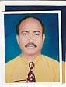 | DR. MD. MAHBUBUR RAHMAN  F/Name:  M/Name:  BM & DC Reg. No:  NID:  Cell:  Address: Lecturer, Anatomy, Mymensingh Medical College, Mymensingh.  Blood Group:
5 | Voter No  LM-4100005  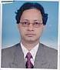 | DR. MD. EHSANUL HAQUE  F/Name:  M/Name:  BM & DC Reg. No:  NID:  Cell:  Address:  Blood Group:
6 | Voter No  LM-4100006 | DR. A.K.M. MAJIBUR RAHMAN KHAN  F/Name:  M/Name:  BM & DC Reg. No:  NID:  Cell:  Address:  Blood Group:
7 | Voter No  LM-4100007  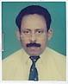 | DR. HARI SARKAR DAS  F/Name:  M/Name:  BM & DC Reg. No:  NID:  Cell:  Address:  Blood Group:
8 | Voter No  LM-4100008  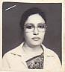 | DR. NASIMA ANWAR  F/Name:  M/Name:  BM & DC Reg. No:  NID:  Cell:  Address:  Blood Group:
9 | Voter No  LM-4100009  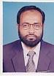 | DR. MIRZA HAMIDUL HUQ  F/Name:  M/Name:  BM & DC Reg. No:  NID:  Cell:  Address: Asst. Prof. of Pathology, Mymensingh Medical College, Mymensingh.  Blood Group:
10 | Voter No  LM-4100010  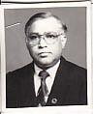 | DR. MOZIBUR RAHMAN FAKIR  F/Name:  M/Name:  BM & DC Reg. No:  NID:  Cell:  Address:  Blood Group:
11 | Voter No  LM-4100011  No Image | DR. AIM MAFAKHKHARUL ISLAM  F/Name:  M/Name:  BM & DC Reg. No:  NID:  Cell:  Address: 2/K, Ismail Road, Mymensingh  Blood Group:  E X P I R E D
12 | Voter No  LM-4100012  No Image | DR. MD. SHAHABUDDIN  F/Name:  M/Name:  BM & DC Reg. No:  NID:  Cell:  Address: Ex. Asst. Prof. of Opthalmology, Mymenshing Medical College, Mymensingh  Blood Group:
13 | Voter No  LM-4100013  No Image | DR. SAYMA AFROZE  F/Name:  M/Name:  BM & DC Reg. No:  NID:  Cell:  Address: M-1, Noorjahan Road, Mohammadpur, Dhaka  Blood Group:
14 | Voter No  LM-4100014  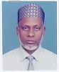 | DR. M.A. KHALEQUE TALUKDER  F/Name:  M/Name:  BM & DC Reg. No:  NID:  Cell:  Address: Charpara, Mymensingh  Blood Group:
15 | Voter No  LM-4100015  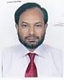 | DR. MUHAMMAD ALI SIDDIQUI  F/Name: Late Sheikh Chand Bepari  M/Name:  BM & DC Reg. No:  NID:  Cell:  Address: 93/C, Baghmara Road, Bhrammpalli, Mymensingh  Blood Group:
16 | Voter No  LM-4100016  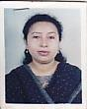 | DR. AFSANA RAUSHAN  F/Name: M.A. Bari  M/Name:  BM & DC Reg. No:  NID:  Cell:  Address: 93/C, Baghmara Road, Bhammapalli, Mymensingh  Blood Group:
17 | Voter No  LM-4100017  No Image | DR. MD. ANWARUL HOQUE CHOWDHURY  F/Name:  M/Name:  BM & DC Reg. No:  NID:  Cell:  Address: Mymenshing Medical College, Mymensingh  Blood Group:
18 | Voter No  LM-4100018  No Image | DR. KAZI MD. ISMAIL  F/Name:  M/Name:  BM & DC Reg. No:  NID:  Cell:  Address: 5/F, Medical Staff Quarter, Charpara, Mymensingh.  Blood Group:  E X P I R E D
19 | Voter No  LM-4100019  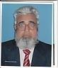 | DR. MD. ABDUL GHANI  F/Name:  M/Name:  BM & DC Reg. No:  NID:  Cell:  Address: Ex. Associate Prof. Medicine, Mymenshing Medical College, Mymensingh  Blood Group:
20 | Voter No  LM-4100020  No Image | DR. MD. JAMSED HAIDER SIDDIQUE  F/Name:  M/Name:  BM & DC Reg. No:  NID:  Cell:  Address: Associate Professor Pathology Sir Salimullah Medical College, Mitford, Dhaka  Blood Group:  TRANSFERED to BMA Dhaka City  LM-1405543
21 | Voter No  LM-4100021  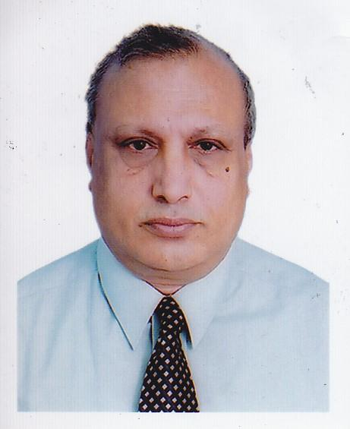 | DR. SHAH MONIR HOSSAIN  F/Name:  M/Name:  BM & DC Reg. No:  NID:  Cell:  Address: Mohakhali, Dhaka  Blood Group:
22 | Voter No  LM-4100022  No Image | DR. MD. SHAFIQUL ISLAM  F/Name:  M/Name:  BM & DC Reg. No:  NID:  Cell:  Address: Registrar (Paed)  200 Beded Hospital  Narayangonj  Blood Group:  TRANSFERED to BMA Dhaka City  LM-1405543
23 | Voter No  LM-4100023  No Image | DR. SHAHAB UDDIN AHMED CHOWDHURY  F/Name:  M/Name:  BM & DC Reg. No:  NID:  Cell:  Address: Hoque Manjil, Charpara, Mymensingh.  Blood Group:
24 | Voter No  LM-4100024  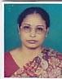 | DR. ANWARA KHANAM  F/Name:  M/Name:  BM & DC Reg. No:  NID:  Cell:  Address: Medical Officer, Pathology Dept. Mymenshing Medical College, Mymensingh.  Blood Group:
25 | Voter No  LM-4100025  No Image | DR. ALIYA RASHID  F/Name:  M/Name:  BM & DC Reg. No:  NID:  Cell:  Address: 2-B, Medical Staff Quarter, Charpara, Mymensingh  Blood Group:
26 | Voter No  LM-4100026  No Image | DR. A.Z.M. ABUL FAZAL  F/Name:  M/Name:  BM & DC Reg. No:  NID:  Cell:  Address: Thana Health & FPO, Sadar, Mymensingh  Blood Group:
27 | Voter No  LM-4100027  No Image | DR. MURSHEDA AKHTER  F/Name:  M/Name:  BM & DC Reg. No:  NID:  Cell:  Address: Administrator MFPC,Mymensingh  Blood Group:
28 | Voter No  LM-4100028  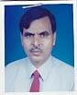 | DR. MD. BELAYET HOSSAIN  F/Name:  M/Name:  BM & DC Reg. No:  NID:  Cell:  Address: 187/C, R.K. Mission Road, Mymensingh  Blood Group:
29 | Voter No  LM-4100029  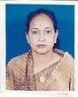 | DR. BILKIS PARVIN  F/Name:  M/Name:  BM & DC Reg. No:  NID:  Cell:  Address: 4/B, Porhit Para, Mymensingh  Blood Group:
30 | Voter No  LM-4100030 | DR. MD. MAHBUBUL KARIM KHAN  F/Name:  M/Name:  BM & DC Reg. No:  NID:  Cell:  Address: 47-B, Baghmara Road, Mymensingh  Blood Group:
31 | Voter No  LM-4100031  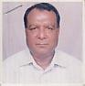 | DR. MD. MAFIZUR RAHMAN  F/Name:  M/Name:  BM & DC Reg. No:  NID:  Cell:  Address: 3/2, Mashkanda, PTI Moor, Mymensingh  Blood Group:
32 | Voter No  LM-4100032  No Image | DR. PRANAB KUMAR AICH  F/Name:  M/Name:  BM & DC Reg. No:  NID:  Cell:  Address: Ex-Dept. of ENT, Mymensingh Medical College, Mymensingh  Blood Group:
33 | Voter No  LM-4100033  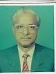 | DR. MD. MAZHARUL HAQ  F/Name:  M/Name:  BM & DC Reg. No:  NID:  Cell:  Address: Ex. Civil Surgeon, Mymensingh  Blood Group:
34 | Voter No  LM-4100034  No Image | DR. MD. GOLAM MUSTAFA  F/Name:  M/Name:  BM & DC Reg. No:  NID:  Cell:  Address: Mita Clinic, Mymensingh  Blood Group:
35 | Voter No  LM-4100035  No Image | DR. MD. NURUL ISLAM  F/Name:  M/Name:  BM & DC Reg. No:  NID:  Cell:  Address: Prof. of Pharm, Mymensingh Medical College, Mymensingh  Blood Group:
36 | Voter No  LM-4100036  No Image | DR. A.K.M. REZAUL ISLAM.  F/Name:  M/Name:  BM & DC Reg. No:  NID:  Cell:  Address: Nisytal Nihar Appartment C-5,  House # 5, Road # 15, (New)  Dhanmondi R/A, Dhaka.  Blood Group:  TRANSFERED to BMA Dhaka City  LM-1405543
37 | Voter No  LM-4100037  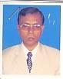 | DR. A.S.M. MEFTAHUZZAMAN  F/Name:  M/Name:  BM & DC Reg. No:  NID:  Cell:  Address: 17, Hindu Polli, Shehora, Mymensingh  Blood Group:
38 | Voter No  LM-4100038  No Image | DR. MD. SAIFUL BARI  F/Name:  M/Name:  BM & DC Reg. No:  NID:  Cell:  Address: 133, R.K. Mission Road, Mymensingh  Blood Group:
39 | Voter No  LM-4100039  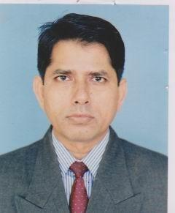 | DR. A.K.M. WALIULLAH  F/Name:  M/Name:  BM & DC Reg. No:  NID:  Cell:  Address: R.K. Mission Road, Mymensingh  Blood Group:
40 | Voter No  LM-4100040  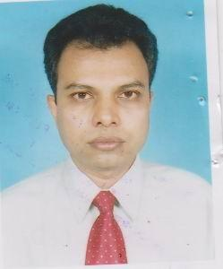 | DR. A.K.M. SAYEEDUL ISLAM  F/Name:  M/Name:  BM & DC Reg. No:  NID:  Cell:  Address: Associate Prof. of Orhto, Mymensingh Medical College, Mymensingh  Blood Group:
41 | Voter No  LM-4100041  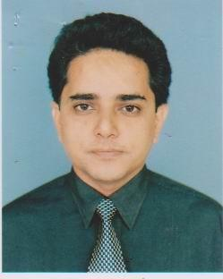 | DR. JAGODIS CHANDRA GHOSH  F/Name:  M/Name:  BM & DC Reg. No:  NID:  Cell:  Address: 9, College Guest House, Mymenshing Medical College, Mymensingh  Blood Group:
42 | Voter No  LM-4100042  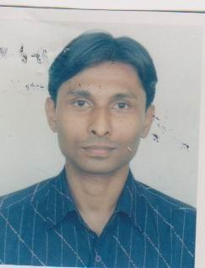 | DR. A.T.M. HUMAYUN  F/Name:  M/Name:  BM & DC Reg. No:  NID:  Cell:  Address: Retd. Asst. Prof. Forensic, Mymensingh Medical College, Mymensingh  Blood Group:
43 | Voter No  LM-4100043 | DR. MOHAMMAD NASEEM KHAN  F/Name:  M/Name:  BM & DC Reg. No:  NID:  Cell:  Address: Muclear Medical Centre, Mymenshing Medical College, Mymensingh  Blood Group:
44 | Voter No  LM-4100044  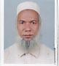 | DR. MD. NURUL HAQUE  F/Name:  M/Name:  BM & DC Reg. No:  NID:  Cell:  Address: Ideal Nursing Home, Valikaser, Mymensingh  Blood Group:
45 | Voter No  LM-4100045  No Image | DR. A.K.M. RUHUL AMIN KHAN  F/Name:  M/Name:  BM & DC Reg. No:  NID:  Cell:  Address: Asst. Prof. Community Medicine, Mymensingh Medical College, Mymensingh  Blood Group:
46 | Voter No  LM-4100046  No Image | DR. BIDHAN CHANDRA ROY  F/Name:  M/Name:  BM & DC Reg. No:  NID:  Cell:  Address: Asst. Prof. of Ortho, Mymenshing Medical College, Mymensingh  Blood Group:
47 | Voter No  LM-4100047  No Image | DR. SYEDA AFROZA KHATUN  F/Name:  M/Name:  BM & DC Reg. No:  NID:  Cell:  Address: Associate Professor (Paed)  House # 11, Road # 2/A  Banani, Dhaka  Blood Group:  TRANSFERED to BMA Dhaka City  LM-1405543
48 | Voter No  LM-4100048  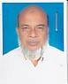 | DR. MD. BADIUZZAMAN  F/Name:  M/Name:  BM & DC Reg. No:  NID:  Cell:  Address: 85, Brahmapalli, Mymensingh  Blood Group:
49 | Voter No  LM-4100049  No Image | DR. MD. SAIFUL ISLAM BHUIYAN  F/Name:  M/Name:  BM & DC Reg. No:  NID:  Cell:  Address: 87, Shehara, Dhopakhola, Mymensingh  Blood Group:
50 | Voter No  LM-4100050  No Image | DR. MD. SHAMSUL HOQUE  F/Name:  M/Name:  BM & DC Reg. No:  NID:  Cell:  Address: TRANSFERED to BMA Faridpur Branch, LM-1700010  Blood Group:  TRANSFERED to BMA Dhaka City  LM-1405543
51 | Voter No  LM-4100051  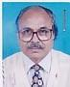 | DR. SHEKH MANUAR HOSSAIN  F/Name:  M/Name:  BM & DC Reg. No:  NID:  Cell:  Address: Asst. Director, DGHS, Mohakhali, Dhaka  Blood Group:
52 | Voter No  LM-4100052  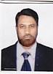 | DR. MUSTAFA KAMAL  F/Name:  M/Name:  BM & DC Reg. No:  NID:  Cell:  Address: 18, Girls School Road, Mymensingh  Blood Group:
53 | Voter No  LM-4100053  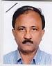 | DR. SANKAR NARAYAN DEY  F/Name:  M/Name:  BM & DC Reg. No:  NID:  Cell:  Address: Radiologist, Mymenshing Medical College, Mymensingh  Blood Group:
54 | Voter No  LM-4100054  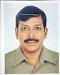 | DR. MUHAMMAD MODEBBER HASHMI  F/Name:  M/Name:  BM & DC Reg. No:  NID:  Cell:  Address: Asst. Prof, Cardiology, Mymensingh Medical College, Mymensingh  Blood Group:
55 | Voter No  LM-4100055  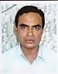 | DR. MD. ABDUL HAKIMSARKER  F/Name:  M/Name:  BM & DC Reg. No:  NID:  Cell:  Address: Medical Officer, MFPC, Mymensingh Medical College, Mymensingh  Blood Group:
56 | Voter No  LM-4100056  No Image | DR. MADHAB CHANDRA PAUL  F/Name:  M/Name:  BM & DC Reg. No:  NID:  Cell:  Address: Asso.Prof. of Anes,Mymenshing Medical College, Mymensingh  Blood Group:
57 | Voter No  LM-4100057  No Image | DR. ASIA A. KHATUN  F/Name:  M/Name:  BM & DC Reg. No:  NID:  Cell:  Address: Ex. Prof. incharge, Obs & Gynae, Mymenshing Medical College, Mymensingh  Blood Group:
58 | Voter No  LM-4100058  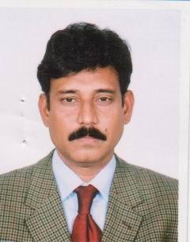 | DR. WAZIUL ALAM CHOWDHURY  F/Name:  M/Name:  BM & DC Reg. No:  NID:  Cell:  Address: Asst. Prof. Dept. of Psycology, Mymenshing Medical College, Mymensingh  Blood Group:
59 | Voter No  LM-4100059  No Image | DR. MD. RESHIDUL HUDA  F/Name:  M/Name:  BM & DC Reg. No:  NID:  Cell:  Address: Medical Officer, Civil Surgeon Office, Mymensingh  Blood Group:
60 | Voter No  LM-4100060  No Image | DR. S.M. SERAJUL AREFIN  F/Name:  M/Name:  BM & DC Reg. No:  NID:  Cell:  Address: Mymenshing Medical College, Mymensingh  Blood Group:
61 | Voter No  LM-4100061  No Image | DR. MD. ANWARUL ISLAM CHOWDHURY  F/Name:  M/Name:  BM & DC Reg. No:  NID:  Cell:  Address: TRANSFERED to BMA Dhaka City, LM-1401992  Asst. Prof. of Ortho. Surgery Dept. BSMMU,Shahbag, Dhaka.  Blood Group:  TRANSFERED to BMA Dhaka City  LM-1405543
62 | Voter No  LM-4100062  No Image | DR. MST. PIARA BEGUM  F/Name:  M/Name:  BM & DC Reg. No:  NID:  Cell:  Address: Asst. Prof. & HD of Ortho, Mymensingh Medical College, Mymensingh  Blood Group:
63 | Voter No  LM-4100063  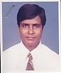 | DR. ANM. FAZLUL HOQ PATHAN  F/Name:  M/Name:  BM & DC Reg. No:  NID:  Cell:  Address: 72/C, Ali Manzil, D.B. Road, Mymensingh  Blood Group:  E X P I R E D
64 | Voter No  LM-4100064  No Image | DR. MD. NIAMUL HAQUE  F/Name:  M/Name:  BM & DC Reg. No:  NID:  Cell:  Address: 1, Maskanda, Mymensingh  Blood Group:
65 | Voter No  LM-4100065  No Image | DR. MD. ANISUR RAHMAN KHAN  F/Name:  M/Name:  BM & DC Reg. No:  NID:  Cell:  Address: 92/1, Nowmahal, Mymensingh  Blood Group:
66 | Voter No  LM-4100066  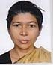 | DR. KALPANA DEB  F/Name:  M/Name:  BM & DC Reg. No:  NID:  Cell:  Address: 29/Cha, Madon Babu Road, Mymensingh  Blood Group:
67 | Voter No  LM-4100067  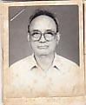 | DR. M.A. GOFFAR TALUKDER  F/Name:  M/Name:  BM & DC Reg. No:  NID:  Cell:  Address: 23, Mashkanda, Mymensingh  Blood Group:
68 | Voter No  LM-4100068  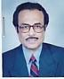 | DR. A.F.M. SIDDIQUR RAHMAN  F/Name:  M/Name:  BM & DC Reg. No:  NID:  Cell:  Address: Director, H. N. Home, 29, Shehora, Mymensingh  Blood Group:
69 | Voter No  LM-4100069  No Image | DR. A.K.M. SHAMSUL ALAM  F/Name:  M/Name:  BM & DC Reg. No:  NID:  Cell:  Address: Associate Prof. (Ane) CMCH Chittagong  Blood Group:  TRANSFERED to BMA Dhaka City  LM-1405543
70 | Voter No  LM-4100070  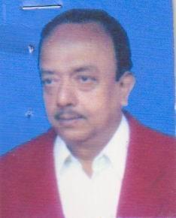 | DR. MD. RUHUL AMIN  F/Name:  M/Name:  BM & DC Reg. No:  NID:  Cell:  Address: Medical Officer, Thana Health Complex, Fulbaria, Mymensingh  Blood Group:
71 | Voter No  LM-4100071  No Image | DR. AFROZA RAHMAN  F/Name:  M/Name:  BM & DC Reg. No:  NID:  Cell:  Address: 3/2, Mashkanda, PTI Moor, Mymensingh  Blood Group:
72 | Voter No  LM-4100072  No Image | DR. MOMINUL HAQUE  F/Name:  M/Name:  BM & DC Reg. No:  NID:  Cell:  Address: 59, Rambabu Road, Mymensingh  Blood Group:
73 | Voter No  LM-4100073  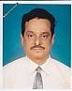 | DR. RANJAN KUMAR MAJUMDER  F/Name:  M/Name:  BM & DC Reg. No:  NID:  Cell:  Address: 187, Kalikari Road, Mymensingh  Blood Group:
74 | Voter No  LM-4100074  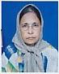 | DR. SYEDA AFIFA HUDA  F/Name:  M/Name:  BM & DC Reg. No:  NID:  Cell:  Address: 85, Brahmanpalli, Mymensingh  Blood Group:
75 | Voter No  LM-4100075  No Image | DR. MD. NURUL AMIN AKANDA  F/Name:  M/Name:  BM & DC Reg. No:  NID:  Cell:  Address: Haque Monjeel, Charpara, Mymensingh. T.F, Netrokona  Blood Group:
76 | Voter No  LM-4100076  No Image | DR. ABIBA AHMED  F/Name:  M/Name:  BM & DC Reg. No:  NID:  Cell:  Address: 4/A/2, Brahmanpally, Mymensingh  Blood Group:
77 | Voter No  LM-4100077  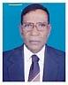 | DR. LT. COLONEL RETD. HAFIZ AHMED  F/Name:  M/Name:  BM & DC Reg. No:  NID:  Cell:  Address: Vill-Harirampur, Trishal, Mymensingh  Blood Group:
78 | Voter No  LM-4100078 | DR. MD. ABDUR RASHID  F/Name:  M/Name:  BM & DC Reg. No:  NID:  Cell:  Address: Civil Surgeon Office, Mymensingh  Blood Group:
79 | Voter No  LM-4100079  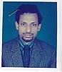 | DR. GAZI ABUL HOSSAIN  F/Name:  M/Name:  BM & DC Reg. No:  NID:  Cell:  Address: Sr. Medical Officer, Nuclear Medicine Center, Mymensingh  Blood Group:
80 | Voter No  LM-4100080  No Image | DR. MD. ABUL FARAH  F/Name:  M/Name:  BM & DC Reg. No:  NID:  Cell:  Address: 257/1, F-4, Navana Brize,  Elephant Road,  Dhaka.  Blood Group:  TRANSFERED to BMA Dhaka City  LM-1405543
81 | Voter No  LM-4100081  No Image | DR. MD. MIZANUR RAHMAN CAESER  F/Name:  M/Name:  BM & DC Reg. No:  NID:  Cell:  Address: EMO. Mymenshing Medical College, Mymensingh  Blood Group:
82 | Voter No  LM-4100082  No Image | DR. MD. ABU ZAFAR SADEK  F/Name:  M/Name:  BM & DC Reg. No:  NID:  Cell:  Address: Thana Health Complex, Muktagacha, Mymensingh  Blood Group:
83 | Voter No  LM-4100083  No Image | DR. MD. NOOR-E-FERDOUS  F/Name:  M/Name:  BM & DC Reg. No:  NID:  Cell:  Address: Thana Health Complex, Muktagacha, Mymensingh  Blood Group:
84 | Voter No  LM-4100084  No Image | DR. MD. ABDUL MUTTALIB  F/Name:  M/Name:  BM & DC Reg. No:  NID:  Cell:  Address: 10/A, Amlapara, Mymensingh  Blood Group:
85 | Voter No  LM-4100085  No Image | DR. MUHAMMED ABDUL QAYYUM ANWAR  F/Name:  M/Name:  BM & DC Reg. No:  NID:  Cell:  Address: Medical Officer, MCH & FP, Haluaghat Health Complex, Mymensingh  Blood Group:
86 | Voter No  LM-4100086  No Image | DR. MD. ABDUR RAFIQUE  F/Name:  M/Name:  BM & DC Reg. No:  NID:  Cell:  Address: TH & FP, Haluaghat Health Complex, Mymensingh  Blood Group:
87 | Voter No  LM-4100087  No Image | DR. MD. BASIRUL AZAM  F/Name:  M/Name:  BM & DC Reg. No: 22269  NID:  Cell: 01712671040  Address: New Hospital Road, Chuadanga.  Blood Group:  TRANSFERED to BMA Dhaka City  LM-1405543
88 | Voter No  LM-4100088  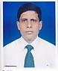 | DR. MD. MANZURUL KARIM KHAN  F/Name:  M/Name:  BM & DC Reg. No:  NID:  Cell:  Address: Registrar, ENT, MMCH, Mymensingh  Blood Group:
89 | Voter No  LM-4100089  No Image | DR. MD. MONWAR HOSSAIN  F/Name:  M/Name:  BM & DC Reg. No:  NID:  Cell:  Address: Asst. Prof. ENT Dept. Mymenshing Medical College, Mymensingh  Blood Group:
90 | Voter No  LM-4100090  No Image | DR. MST. RAHIMA KHATUN  F/Name:  M/Name:  BM & DC Reg. No:  NID:  Cell:  Address: Munshirhat, R. D. Dhobaura, Mymensingh  Blood Group:
91 | Voter No  LM-4100091  No Image | DR. MASUDA ATIKA KHATUN  F/Name:  M/Name:  BM & DC Reg. No:  NID:  Cell:  Address: Microbiology Dept. Mymenshing Medical College, Mymensingh  Blood Group:
92 | Voter No  LM-4100092  No Image | DR. MAIN MD. MATIUR RAHMAN  F/Name:  M/Name:  BM & DC Reg. No:  NID:  Cell:  Address: Pathology, Mymenshing Medical College, Mymensingh  Blood Group:
93 | Voter No  LM-4100093  No Image | DR. SAYEDA MAHMUDA  F/Name:  M/Name:  BM & DC Reg. No:  NID:  Cell:  Address: Psychiatry, Mymenshing Medical College, Mymensingh  Blood Group:
94 | Voter No  LM-4100094  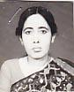 | DR. MAHFUZA HOSSAIN  F/Name:  M/Name:  BM & DC Reg. No:  NID:  Cell:  Address: Pediatric, Outdoor, Mymenshing Medical College, Mymensingh  Blood Group:
95 | Voter No  LM-4100095  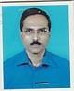 | DR. MD. ANWARUL ISLAM CHOWDURY  F/Name:  M/Name:  BM & DC Reg. No:  NID:  Cell:  Address: 167/B, R.K. Mission Road, Mymensingh  Blood Group:
96 | Voter No  LM-4100096  No Image | DR. MD. ABDUL KHALEQUE TALUKDER  F/Name:  M/Name:  BM & DC Reg. No:  NID:  Cell:  Address: Civil Surgeon  Narsingdi.  Blood Group:  TRANSFERED to BMA Dhaka City  LM-1405543
97 | Voter No  LM-4100097  No Image | DR. MD. HASMAT ALI  F/Name:  M/Name:  BM & DC Reg. No:  NID:  Cell:  Address: Thana Health Complex, Bhaluka, Mymensingh  Blood Group:
98 | Voter No  LM-4100098  No Image | DR. LIAQUAT ALI KHAN  F/Name:  M/Name:  BM & DC Reg. No:  NID:  Cell:  Address: 396, West Kefrul, Dhaka  Blood Group:
99 | Voter No  LM-4100099  No Image | DR. A.K.M. MONJURUL HAQUE  F/Name:  M/Name:  BM & DC Reg. No:  NID:  Cell:  Address: Thana Health Complex, Bhaluka, Mymensingh  Blood Group:
100 | Voter No  LM-4100100  No Image | DR. SUBODH CHANDRA DAS  F/Name:  M/Name:  BM & DC Reg. No:  NID:  Cell:  Address: TRANSFERED to BMA Dhaka City, LM- 1404056  Blood Group:  TRANSFERED to BMA Dhaka City  LM-1405543
101 | Voter No  LM-4100101  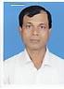 | DR. MD. ABDUR RAHIM  F/Name:  M/Name:  BM & DC Reg. No:  NID:  Cell:  Address: 2, Z.A. College Road, Gohail Kandi, Mymensingh  Blood Group:
102 | Voter No  LM-4100102  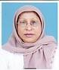 | DR. RASHIDA AKHTER KHATOON  F/Name:  M/Name:  BM & DC Reg. No:  NID:  Cell:  Address: 65, Pandit Para, Mymensingh  Blood Group:
103 | Voter No  LM-4100103  No Image | DR. SAIYEEDUR RAHMAN  F/Name:  M/Name:  BM & DC Reg. No:  NID:  Cell:  Address: House # 22,Boundary Road, Mymensingh.  Blood Group:
104 | Voter No  LM-4100104  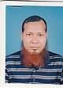 | DR. MD. NAZRUL ISLAM  F/Name:  M/Name:  BM & DC Reg. No:  NID:  Cell:  Address: 32, Brahmapalli, Mymensingh  Blood Group:
105 | Voter No  LM-4100105  No Image | DR. MD. MUZAMMEL HAQUE  F/Name:  M/Name:  BM & DC Reg. No:  NID:  Cell:  Address: Akua Madrasa Quarter, Phulbaria Road, Mymensingh  Blood Group:
106 | Voter No  LM-4100106  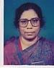 | DR. LILY BILKIS  F/Name:  M/Name:  BM & DC Reg. No:  NID:  Cell:  Address: Akua Madrasa Quarter, Phulbaria Road, Mymensingh  Blood Group:
107 | Voter No  LM-4100107  No Image | DR. MD. NAZRUL ISLAM SIDDIQUI  F/Name:  M/Name:  BM & DC Reg. No:  NID:  Cell:  Address: Mymenshing Medical College, Mymensingh  Blood Group:
108 | Voter No  LM-4100108  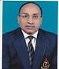 | DR. MD. ABDUR ROUF  F/Name:  M/Name:  BM & DC Reg. No:  NID:  Cell:  Address: 78, Chamjragudam Road, Sohora, Mymensingh  Blood Group:
109 | Voter No  LM-4100109  No Image | DR. ABDULLAH AKHTER AHMED  F/Name:  M/Name:  BM & DC Reg. No:  NID:  Cell:  Address: Dept. of Microbiology, Mymenshing Medical College, Mymensingh  Blood Group:
110 | Voter No  LM-4100110  No Image | DR. NAHEED ARA BEGUM  F/Name:  M/Name:  BM & DC Reg. No:  NID:  Cell:  Address: 2D, Medical Staff Quarter, Charpara, Mymensingh  Blood Group:
111 | Voter No  LM-4100111  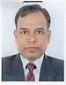 | DR. ATM. BAHAR UDDIN  F/Name:  M/Name:  BM & DC Reg. No:  NID:  Cell:  Address: Lecturer, Biochemistry, Mymenshing Medical College, Mymensingh  Blood Group:
112 | Voter No  LM-4100112  No Image | DR. ASHEK AHAMED SHAHID REZA  F/Name:  M/Name:  BM & DC Reg. No:  NID:  Cell:  Address: Lecturer, Community Medicine, Mymenshing Medical College, Mymensingh  Blood Group:
113 | Voter No  LM-4100113  No Image | DR. MD. KAMAL UDDIN  F/Name:  M/Name:  BM & DC Reg. No:  NID:  Cell:  Address: Radiotherapy Unit, Mymenshing Medical College, Mymensingh  Blood Group:
114 | Voter No  LM-4100114  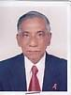 | DR. MD. AZIZUR RAHMAN  F/Name:  M/Name:  BM & DC Reg. No:  NID:  Cell:  Address: 49/C, Bagmara Road, Mymensingh  Blood Group:
115 | Voter No  LM-4100115  No Image | DR. ANM. BAZLUR RAHMAN  F/Name:  M/Name:  BM & DC Reg. No:  NID:  Cell:  Address: Trishal, Mymensingh  Blood Group:
116 | Voter No  LM-4100116  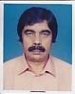 | DR. A.B.M. ERSHADUL KARIM  F/Name:  M/Name:  BM & DC Reg. No:  NID:  Cell:  Address: 20/A, Makorjani Lane, Mymensingh  Blood Group:
117 | Voter No  LM-4100117  No Image | DR. MD. ALI AKBAR TALUKDER  F/Name:  M/Name:  BM & DC Reg. No:  NID:  Cell:  Address: 47/A, Nutan Bazar, Mymensingh  Blood Group:
118 | Voter No  LM-4100118  No Image | DR. A.K.M. MUSA SHAHEEN  F/Name:  M/Name:  BM & DC Reg. No:  NID:  Cell:  Address: 110/C, R.K. Mission Road, Mymensingh  Blood Group:
119 | Voter No  LM-4100119  No Image | DR. LAILA ANJUMAN BANU  F/Name:  M/Name:  BM & DC Reg. No:  NID:  Cell:  Address: Mymenshing Medical College, Mymensingh  Blood Group:
120 | Voter No  LM-4100120  No Image | DR. DIL AFROZ RAHMAN  F/Name:  M/Name:  BM & DC Reg. No:  NID:  Cell:  Address: Deputy Director, Mymenshing Medical College, Mymensingh  Blood Group:
121 | Voter No  LM-4100121 | DR. MD. ISMAIL HOSSAIN  F/Name:  M/Name:  BM & DC Reg. No:  NID:  Cell:  Address: 4/C, Staff Quarter, Charpara, Mymensingh  Blood Group:
122 | Voter No  LM-4100122  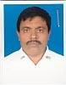 | DR. MD. KHADEMUL ISLAM  F/Name: Dr. Nasim Uddin Miah  M/Name:  BM & DC Reg. No: 7002  NID:  Cell:  Address: Haque Nursing Home, 77/B, Bagmara, Mymensingh  Blood Group:
123 | Voter No  LM-4100123  No Image | DR. MD. GOLAM FARUK HOSSAIN  F/Name:  M/Name:  BM & DC Reg. No:  NID:  Cell:  Address: 37, Brahmapalli, Mymensingh  Blood Group:
124 | Voter No  LM-4100124  No Image | DR. M.N.A. MAHMUDA KHATUN  F/Name:  M/Name:  BM & DC Reg. No:  NID:  Cell:  Address: 11/E, Bonni Staff Quarter, Charpara, Mymensingh  Blood Group:
125 | Voter No  LM-4100125  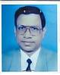 | DR. SYED MD. HABIBULLAH  F/Name:  M/Name:  BM & DC Reg. No:  NID:  Cell:  Address: 131, Kalibari Road, Patgodam, Mymensingh  Blood Group:
126 | Voter No  LM-4100126  No Image | DR. MD. RAJAB ALI  F/Name:  M/Name:  BM & DC Reg. No:  NID:  Cell:  Address: 69, Rambabu Road, Mymensingh  Blood Group:
127 | Voter No  LM-4100127  No Image | DR. SM. SHOUKAT ALI  F/Name:  M/Name:  BM & DC Reg. No:  NID:  Cell:  Address: 63/D, Purohitpara, Mymensingh  Blood Group:
128 | Voter No  LM-4100128  No Image | DR. A.E.M. MAZHARUL ISLAM  F/Name:  M/Name:  BM & DC Reg. No:  NID:  Cell:  Address: 63/D, Purohitpara, Mymensingh  Blood Group:
129 | Voter No  LM-4100129  No Image | DR. SM. SHARIF UDDIN PATHAN  F/Name:  M/Name:  BM & DC Reg. No:  NID:  Cell:  Address: 156/A, R.K. Mission Road, Mymensingh  Blood Group:
130 | Voter No  LM-4100130  No Image | DR. MD. AMINUL ISLAM  F/Name:  M/Name:  BM & DC Reg. No:  NID:  Cell:  Address: Radiotherapy Dept. Mymenshing Medical College, Mymensingh  Blood Group:
131 | Voter No  LM-4100131  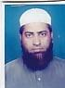 | DR. FAIZ AHMED  F/Name:  M/Name:  BM & DC Reg. No:  NID:  Cell:  Address: Dr. Medical Officer, Agri Versity, Mymensingh  Blood Group:
132 | Voter No  LM-4100132  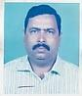 | DR. GOPAL CHANDRA DAS  F/Name:  M/Name:  BM & DC Reg. No:  NID:  Cell:  Address: 17, Gulkibari Road, Mymensingh  Blood Group:
133 | Voter No  LM-4100133  No Image | DR. MD. ALAUDDIN AL AZAD  F/Name:  M/Name:  BM & DC Reg. No:  NID:  Cell:  Address: TRANSFERED to BMA Kurigram Branch  Blood Group:  TRANSFERED to BMA Dhaka City  LM-1405543
134 | Voter No  LM-4100134  No Image | DR. ABDUS SAMAD SHAIKH  F/Name:  M/Name:  BM & DC Reg. No:  NID:  Cell:  Address: Asst. Prof. Opthalmology, Mymenshing Medical College, Mymensingh  Blood Group:
135 | Voter No  LM-4100135  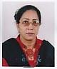 | DR. KOHINOOR AKHTER BANU  F/Name:  M/Name:  BM & DC Reg. No:  NID:  Cell:  Address: 9, Omed Ali Road, Dopakuler More, Mymensingh  Blood Group:
136 | Voter No  LM-4100136  No Image | DR. MD. HAZRAT ALI  F/Name:  M/Name:  BM & DC Reg. No:  NID:  Cell:  Address: 32/A, Barhmapolli, Mymensingh  Blood Group:
137 | Voter No  LM-4100137  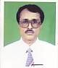 | DR. SUJIT KUMAR CHANDA APU  F/Name:  M/Name:  BM & DC Reg. No:  NID:  Cell:  Address: Kanihari Road, Trisal, Mymensingh  Blood Group:
138 | Voter No  LM-4100138  No Image | DR. MD. ENAMUL HOQUE  F/Name:  M/Name:  BM & DC Reg. No:  NID:  Cell:  Address: Tranesferd to BMA Faridpur Branch, LM-1700030  Blood Group:  TRANSFERED to BMA Dhaka City  LM-1405543
139 | Voter No  LM-4100139  No Image | DR. MD. ASADUZZAMAN  F/Name:  M/Name:  BM & DC Reg. No:  NID:  Cell:  Address: Vill-Chamurkhan, Kanchkura, Mymensingh  Blood Group:
140 | Voter No  LM-4100140  No Image | DR. SHOWKAT ARA  F/Name:  M/Name:  BM & DC Reg. No:  NID:  Cell:  Address: Gynae Dept. Mymenshing Medical College, Mymensingh  Blood Group:
141 | Voter No  LM-4100141  No Image | DR. MD. YEAMLI KHAN  F/Name:  M/Name:  BM & DC Reg. No:  NID:  Cell:  Address: Medical Officer Sadar Hospital Brahmanbaria  Blood Group:  TRANSFERED to BMA Dhaka City  LM-1405543
142 | Voter No  LM-4100142  No Image | DR. MD. MASUD ANWAR BHUIYAN  F/Name:  M/Name:  BM & DC Reg. No:  NID:  Cell:  Address: 522, Ashkona, Uttara, Dhaka  Blood Group:
143 | Voter No  LM-4100143  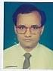 | DR. SANJIB KUMAR CHAKRABORTY  F/Name:  M/Name:  BM & DC Reg. No:  NID:  Cell:  Address: 32/2, Rambabu Road, Mymensingh  Blood Group:
144 | Voter No  LM-4100144  No Image | DR. MD. ABDUL HAMID (SELIM)  F/Name:  M/Name:  BM & DC Reg. No:  NID:  Cell:  Address: Feroza Mansion, 9, Omed Ali Road, Mymensingh  Blood Group:
145 | Voter No  LM-4100145  No Image | DR. MD. MIZANUR RAHMAN  F/Name:  M/Name:  BM & DC Reg. No:  NID:  Cell:  Address: 47, R.K. Mission Road, Mymensingh  Blood Group:
146 | Voter No  LM-4100146  No Image | DR. S.M. BAKHTIAR KAMAL  F/Name: Sk. Md. Abdul Kader  M/Name:  BM & DC Reg. No:  NID:  Cell:  Address: 62, West Nakhalpara, Dhaka  Blood Group:
147 | Voter No  LM-4100147  No Image | DR. MD. MIZANUR RAHMAN  F/Name:  M/Name:  BM & DC Reg. No: 17182  NID:  Cell:  Address: 323, East Nakhalpara, Habiganj House Tejgaon, Dhaka  Blood Group:  TRANSFERED to BMA Dhaka City  LM-1405543
148 | Voter No  LM-4100148  No Image | DR. MD. LIAQUATUNNOR  F/Name:  M/Name:  BM & DC Reg. No:  NID:  Cell:  Address: Noor Manzil, Chandipasha, Nandail, Mymensingh  Blood Group:
149 | Voter No  LM-4100149  No Image | DR. MD. ZINNU RAIN (NEWTON)  F/Name:  M/Name:  BM & DC Reg. No:  NID:  Cell:  Address: 62, Aqua Madrasha Quarter, Mymensingh  Blood Group:
150 | Voter No  LM-4100150  No Image | DR. ABU HENA MUSTAFA KAMAL  F/Name:  M/Name:  BM & DC Reg. No:  NID:  Cell:  Address: 24, Lichu Bagan, Akua Madrasha Quarter, Mymensingh  Blood Group:
151 | Voter No  LM-4100151  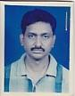 | DR. MD. MAKSUDUR RAHMAN  F/Name:  M/Name:  BM & DC Reg. No:  NID:  Cell:  Address: Charpara, Mymensingh  Blood Group:
152 | Voter No  LM-4100152  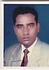 | DR. A.F.M. SALEH (IQBAL)  F/Name:  M/Name:  BM & DC Reg. No:  NID:  Cell:  Address: 1/B, Saroda Ghosh Road, Mymensingh  Blood Group:
153 | Voter No  LM-4100153  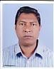 | DR. MD. ABDUL KARIM BHUIYAN  F/Name:  M/Name:  BM & DC Reg. No:  NID:  Cell:  Address: Shohagi H&F WC, Ishwargonj, Mymensingh  Blood Group:
154 | Voter No  LM-4100154  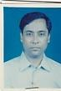 | DR. BABUL CHANDRA DEY  F/Name: Late Bijoy Chandra Dey  M/Name:  BM & DC Reg. No:  NID:  Cell:  Address: 63, R.K. Mission Road, Nowmahal, Mymensingh-2200.  Blood Group:
155 | Voter No  LM-4100155  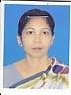 | DR. JINNATUN NUR  F/Name:  M/Name:  BM & DC Reg. No:  NID:  Cell:  Address: 186, Medical Gate, Charpara, Mymensingh  Blood Group:
156 | Voter No  LM-4100156  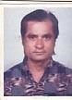 | DR. PRADIPESH CHAKRABARTY  F/Name:  M/Name:  BM & DC Reg. No:  NID:  Cell:  Address: 21, AB. Moharaja Road, Mymensingh  Blood Group:
157 | Voter No  LM-4100157 | DR. SHIKHA RUDRA  F/Name:  M/Name:  BM & DC Reg. No:  NID:  Cell:  Address: 21, AB. Moharaja Road, Mymensingh  Blood Group:
158 | Voter No  LM-4100158  No Image | DR. MD. HARUN AR RASHID  F/Name:  M/Name:  BM & DC Reg. No:  NID:  Cell:  Address: Dental Surgeon, Mymenshing Medical College, Mymensingh (Dental Surgeon is Not Voter)  Blood Group:
159 | Voter No  LM-4100159  No Image | DR. TAPAN KUMAR SAHA  F/Name:  M/Name:  BM & DC Reg. No:  NID:  Cell:  Address: General Hospital, Tangail.,  Blood Group:  TRANSFERED to BMA Dhaka City  LM-1405543
160 | Voter No  LM-4100160  No Image | DR. JAHAR LAL CHOWDHURY  F/Name:  M/Name:  BM & DC Reg. No:  NID:  Cell:  Address: Thana Health Complex, Muktagacha, Mymensingh  Blood Group:
161 | Voter No  LM-4100161  No Image | DR. GOLAM KIBRIA CHOWDHURY  F/Name:  M/Name:  BM & DC Reg. No:  NID:  Cell:  Address: Medical Officer  THC, Araihazar  Narayangonj  Blood Group:  TRANSFERED to BMA Dhaka City  LM-1405543
162 | Voter No  LM-4100162  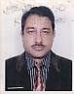 | DR. A.K.M ABDUR RAB.  F/Name:  M/Name:  BM & DC Reg. No:  NID:  Cell:  Address: Thana Health Complex, Nandail, Mymensingh  Blood Group:
163 | Voter No  LM-4100163  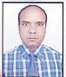 | DR. MD. MUKLESUR RAHMAN KHAN  F/Name:  M/Name:  BM & DC Reg. No:  NID:  Cell:  Address: 35, Zilla School Road, Mymensingh  Blood Group:
164 | Voter No  LM-4100164  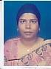 | DR. LUTFUN NAHAR  F/Name:  M/Name:  BM & DC Reg. No:  NID:  Cell:  Address: 4/E, Staff Quarter, Charpara, Mymensingh  Blood Group:
165 | Voter No  LM-4100165  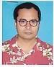 | DR. GOPAL CHANDRA DAS  F/Name:  M/Name:  BM & DC Reg. No:  NID:  Cell:  Address: Muktagacha, Mymensingh  Blood Group:
166 | Voter No  LM-4100166  No Image | DR. MD. ZAHID HOSSAIN  F/Name:  M/Name:  BM & DC Reg. No:  NID:  Cell:  Address: Sahara Pharmacy, Balashpur Bazar, Mymensingh  Blood Group:
167 | Voter No  LM-4100167 | DR. MD. AMZAD ALI FAKIR  F/Name:  M/Name:  BM & DC Reg. No:  NID:  Cell:  Address: Kashiganj SC, Phulpur, Mymensingh  Blood Group:
168 | Voter No  LM-4100168  No Image | DR. A.H.M. AZIZUL HOQUE  F/Name:  M/Name:  BM & DC Reg. No:  NID:  Cell:  Address: R.M.O. Phulpur, Thana Health Complex, Mymensingh  Blood Group:
169 | Voter No  LM-4100169  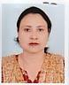 | DR. FARHANA NOMAN  F/Name:  M/Name:  BM & DC Reg. No:  NID:  Cell:  Address: 7, Gohail Kandi, Mymensingh  Blood Group:
170 | Voter No  LM-4100170  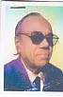 | DR. MUHAMMAD HASAN ALI KHAN  F/Name:  M/Name:  BM & DC Reg. No:  NID:  Cell:  Address: Muktagacha, Mymensingh  Blood Group:
171 | Voter No  LM-4100171  No Image | DR. NIGHAR RASHID  F/Name:  M/Name:  BM & DC Reg. No:  NID:  Cell:  Address: 77/7, Officers Quarter, Mymensingh  Blood Group:
172 | Voter No  LM-4100172  No Image | DR. MD. GHIAS UDDIN  F/Name:  M/Name:  BM & DC Reg. No:  NID:  Cell:  Address: TH & FPO, Thana Health Complex, Ishwargonj, Mymensingh.  Blood Group:
173 | Voter No  LM-4100173  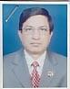 | DR. MD. MUMTAZ UDDIN BHUIYAN  F/Name:  M/Name:  BM & DC Reg. No:  NID:  Cell:  Address: TH & FPO, Thana Health Complex, Nandail, Mymensingh  Blood Group:
174 | Voter No  LM-4100174  No Image | DR. PIJUSH KUMAR CHAKRABARTY  F/Name: Jatendra Chakraborty  M/Name:  BM & DC Reg. No:  NID:  Cell:  Address: Mymenshing Medical College, Mymensingh  Blood Group:
175 | Voter No  LM-4100175  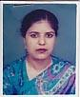 | DR. ROUSHON ARA KHATUN  F/Name:  M/Name:  BM & DC Reg. No:  NID:  Cell:  Address: M.F.P.C, Mymensingh  Blood Group:
176 | Voter No  LM-4100176  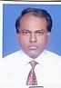 | DR. ATM. HAMIDUL HOQUE  F/Name:  M/Name:  BM & DC Reg. No:  NID:  Cell:  Address: 9, Omed Ali Road, Dopakhola, Mymensingh  Blood Group:
177 | Voter No  LM-4100177  No Image | DR. MD. SERAJUL ISLAM  F/Name:  M/Name:  BM & DC Reg. No:  NID:  Cell:  Address: TH & FPO, Mitamoin, Mymensingh  Blood Group:
178 | Voter No  LM-4100178  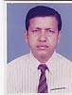 | DR. MD. ABDUL ELAHAB  F/Name:  M/Name:  BM & DC Reg. No:  NID:  Cell:  Address: 19, R.K. Mission Road, Mymensingh  Blood Group:
179 | Voter No  LM-4100179  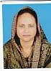 | DR. ANWARA AKHTER  F/Name:  M/Name:  BM & DC Reg. No:  NID:  Cell:  Address: 19, R.K. Mission Road, Mymensingh  Blood Group:
180 | Voter No  LM-4100180  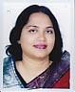 | DR. SHAMIMA ANIS  F/Name:  M/Name:  BM & DC Reg. No:  NID:  Cell:  Address: Medical Officer, FW, Rasulpur, FWC, Gaffargaon, Mymensingh  Blood Group:
181 | Voter No  LM-4100181  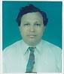 | DR. MD. SHAHADAT HOSSAIN  F/Name:  M/Name:  BM & DC Reg. No:  NID:  Cell:  Address: Amin Pharmacy, 11, Durgapur, Mymensingh  Blood Group:
182 | Voter No  LM-4100182  No Image | DR. QUAMRUZZAMAN  F/Name:  M/Name:  BM & DC Reg. No:  NID:  Cell:  Address: Medical Officer, Shanki Banga USC, Thana Health Complex, Mymensingh  Blood Group:
183 | Voter No  LM-4100183  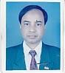 | DR. MD. MANIRUZZAMAN  F/Name:  M/Name:  BM & DC Reg. No:  NID:  Cell:  Address: 66/A, Al-Amin Bhaban, Baghmara, Mymensingh  Blood Group:
184 | Voter No  LM-4100184  No Image | DR. MD. KAMRUL AHSAN  F/Name:  M/Name:  BM & DC Reg. No:  NID:  Cell:  Address: 25, Choto Bazar, Mymensingh  Blood Group:
185 | Voter No  LM-4100185  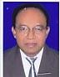 | DR. MD. MAHBUBUL HOQUE  F/Name:  M/Name:  BM & DC Reg. No:  NID:  Cell:  Address: EMO, Mymenshing Medical College, Mymensingh  Blood Group:
186 | Voter No  LM-4100186  No Image | DR. MD. ABUL MANSUR  F/Name:  M/Name:  BM & DC Reg. No:  NID:  Cell:  Address: 22/6, C.K. Ghosh Road, Mymensingh  Blood Group:
187 | Voter No  LM-4100187  No Image | DR. MD. MASHIUR RAHMAN (KHOKA)  F/Name:  M/Name:  BM & DC Reg. No:  NID:  Cell:  Address: Civil Surgeon Office, Mymensingh  Blood Group:
188 | Voter No  LM-4100188  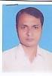 | DR. TARUN KUMAR DHAR  F/Name:  M/Name:  BM & DC Reg. No:  NID:  Cell:  Address: 12, CAB. Guha Road, Ganginarpar, Mymensingh  Blood Group:
189 | Voter No  LM-4100189  No Image | DR. MD. ZAHRUL HOQUE  F/Name:  M/Name:  BM & DC Reg. No:  NID:  Cell:  Address: TH & FPO, Nikly, Mymensingh  Blood Group:
190 | Voter No  LM-4100190  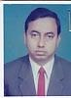 | DR. M.A. GAFUR MIAH  F/Name:  M/Name:  BM & DC Reg. No:  NID:  Cell:  Address: Asst. Prof. Surgery, Mymenshing Medical College, Mymensingh  Blood Group:
191 | Voter No  LM-4100191  No Image | DR. MOHAMMAD AKRAM HOSSAIN  F/Name:  M/Name:  BM & DC Reg. No:  NID:  Cell:  Address: 4/C, Madical Staff Quarter, Charpara, Mymensingh  Blood Group:
192 | Voter No  LM-4100192  No Image | DR. NILUFAR BEGUM  F/Name:  M/Name:  BM & DC Reg. No:  NID:  Cell:  Address: Agriculture University Campus, Mymensingh  Blood Group:
193 | Voter No  LM-4100193  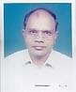 | DR. PARESH NATH PRASAD  F/Name:  M/Name:  BM & DC Reg. No:  NID:  Cell:  Address: 170/A, Kalibari Road, Mymensingh  Blood Group:
194 | Voter No  LM-4100194  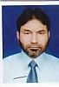 | DR. MD. SADEQUEL ISLAM TALUKDER  F/Name:  M/Name:  BM & DC Reg. No:  NID:  Cell:  Address: Dept. of Pathology, Mymenshing Medical College, Mymensingh  Blood Group:
195 | Voter No  LM-4100195  No Image | DR. FERDOUS ALAM SHIBIB  F/Name:  M/Name:  BM & DC Reg. No:  NID:  Cell:  Address: Thana Health Complex, Muktagaha, Mymensingh  Blood Group:
196 | Voter No  LM-4100196  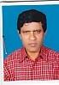 | DR. MD. SIRAJUL ISLAM KHAN.  F/Name:  M/Name:  BM & DC Reg. No:  NID:  Cell:  Address: Thana Health Complex, Fulbaria, Mymensingh  Blood Group:
197 | Voter No  LM-4100197  No Image | DR. A.B.M. AZIZUL ISLAM  F/Name:  M/Name:  BM & DC Reg. No:  NID:  Cell:  Address: Civil Surgeon, Kisoregonj.  Blood Group:  TRANSFERED to BMA Dhaka City  LM-1405543
198 | Voter No  LM-4100198  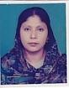 | DR. REBEKA SULTANA  F/Name:  M/Name:  BM & DC Reg. No:  NID:  Cell:  Address: Khwaja Monzeel, 32, Bara Bazar, Mymensingh  Blood Group:
199 | Voter No  LM-4100199  No Image | DR. MD. HABIBUR RAHMAN  F/Name:  M/Name:  BM & DC Reg. No:  NID:  Cell:  Address: Dhobaura, Mymensingh  Blood Group:
200 | Voter No  LM-4100200  No Image | DR. MD. MOMINUL HAQUE  F/Name:  M/Name:  BM & DC Reg. No:  NID:  Cell:  Address: Dinajpur  Blood Group:  TRANSFERED to BMA Dhaka City  LM-1405543
201 | Voter No  LM-4100201  No Image | DR. A.K.M. SIDDIQUR RAHMAN  F/Name:  M/Name:  BM & DC Reg. No:  NID:  Cell:  Address: Cantt. Road, Shankipara, Mymensingh  Blood Group:
202 | Voter No  LM-4100202  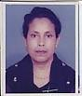 | DR. ANOWARA BEGUM  F/Name:  M/Name:  BM & DC Reg. No:  NID:  Cell:  Address: 26, Kachijully, Jail Road, Mymensingh  Blood Group:
203 | Voter No  LM-4100203  No Image | DR. HOSNE ARA BEGUM  F/Name:  M/Name:  BM & DC Reg. No:  NID:  Cell:  Address: Cantt. Road Shankipara, Mymensingh  Blood Group:
204 | Voter No  LM-4100204  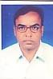 | DR. MD. OBAIDUL ALAM  F/Name:  M/Name:  BM & DC Reg. No:  NID:  Cell:  Address:  Blood Group:
205 | Voter No  LM-4100205  No Image | DR. MD. DELWAR HOSSAIN  F/Name:  M/Name:  BM & DC Reg. No:  NID:  Cell:  Address: Mymenshing Medical College, Mymensingh  Blood Group:
206 | Voter No  LM-4100206  No Image | DR. JAHIR UDDIN MOHAMMOD  F/Name:  M/Name:  BM & DC Reg. No:  NID:  Cell:  Address: 17, Karkun Bari Lane, Dhaka  Blood Group:
207 | Voter No  LM-4100207  No Image | DR. MD. MANIRUZZAMAN  F/Name:  M/Name:  BM & DC Reg. No:  NID:  Cell:  Address: Mymensingh  Blood Group:
208 | Voter No  LM-4100208  No Image | DR. MD. ANWARUZZAMAN  F/Name: M. Abul Khair  M/Name:  BM & DC Reg. No:  NID:  Cell:  Address: Lecturer of Pathology, MMCH, Mymensingh  Blood Group:
209 | Voter No  LM-4100209  No Image | DR. MD. ROFIQUL AKHTER  F/Name:  M/Name:  BM & DC Reg. No:  NID:  Cell:  Address: Associate Prof. Pharmacology, Mymenshing Medical College, Mymensingh  Blood Group:
210 | Voter No  LM-4100210  No Image | DR. MD. ABDUR ROQUIB  F/Name:  M/Name:  BM & DC Reg. No:  NID:  Cell:  Address: 46, Senbari Road, Mymensingh  Blood Group:
211 | Voter No  LM-4100211  No Image | DR. MD. ABDUL QUDDUS  F/Name:  M/Name:  BM & DC Reg. No:  NID:  Cell:  Address: Medical Officer, Putijana SC, Fulbaria, Mymensingh  Blood Group:
212 | Voter No  LM-4100212  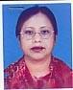 | DR. RABEYA BEGUM  F/Name:  M/Name:  BM & DC Reg. No:  NID:  Cell:  Address: E/29/1, Bangladesh Agriculture Univ, Mymensingh  Blood Group:
213 | Voter No  LM-4100213 | DR. PRADIP CHANDRA KAR  F/Name:  M/Name:  BM & DC Reg. No:  NID:  Cell:  Address: 7/A, Jamir Munshi Lane, Mymensingh  Blood Group:
214 | Voter No  LM-4100214  No Image | DR. A.K.M. MOQSUDUL HASAN  F/Name:  M/Name:  BM & DC Reg. No:  NID:  Cell:  Address: TRANSFERED to BMA Netrokona Branch  Blood Group:  TRANSFERED to BMA Dhaka City  LM-1405543
215 | Voter No  LM-4100215  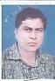 | DR. MD. TAZUL ISLAM  F/Name:  M/Name:  BM & DC Reg. No:  NID:  Cell:  Address: Thana Health Complex, Nandail, Mymensingh  Blood Group:
216 | Voter No  LM-4100216  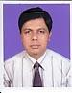 | DR. DULAL CHANDRA PAUL  F/Name:  M/Name:  BM & DC Reg. No:  NID:  Cell:  Address: Touhid Building, Charpara, Mymensingh  Blood Group:
217 | Voter No  LM-4100217  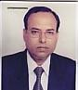 | DR. H. A. GULANDAZ (TARA)  F/Name:  M/Name:  BM & DC Reg. No:  NID:  Cell: 01711355637  Address: Bashumdhara Hospital (Pvt.), 84/1, Brammapolli, Mymensingh  Blood Group:
218 | Voter No  LM-4100218  No Image | DR. DILIP KUMAR DHOR  F/Name:  M/Name:  BM & DC Reg. No:  NID:  Cell:  Address: TRANSFERED to BMA Dhaka City LM-2850  Blood Group:  TRANSFERED to BMA Dhaka City  LM-1405543
219 | Voter No  LM-4100219  No Image | DR. MD. MUZIBUR RAHMAN KHAN  F/Name:  M/Name:  BM & DC Reg. No:  NID:  Cell:  Address: 1, Boundary Road, Mymensingh  Blood Group:
220 | Voter No  LM-4100220  No Image | DR. MD. AKBAR ALI  F/Name:  M/Name:  BM & DC Reg. No:  NID:  Cell:  Address: Civil Surgeon Office, Mymensingh  Blood Group:
221 | Voter No  LM-4100221  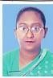 | DR. KAMRUN NAHAR  F/Name:  M/Name:  BM & DC Reg. No:  NID:  Cell:  Address: 2, Umed Ali Road, Mymensingh  Blood Group:
222 | Voter No  LM-4100222  No Image | DR. PARBATI RARI AGARWALA  F/Name:  M/Name:  BM & DC Reg. No:  NID:  Cell:  Address: Srabesh Maharaja Road, Muktagacha, Mymensingh  Blood Group:
223 | Voter No  LM-4100223  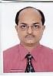 | DR. MIRZA MANJURUL HAQUE  F/Name: Late Emdadul Haque Mirza  M/Name:  BM & DC Reg. No: 10827  NID:  Cell:  Address: 15, Gobindo, Gangolee Road, Mymensingh  Blood Group:
224 | Voter No  LM-4100224  No Image | DR. MOHAMMAD SYEDUR RAHMAN  F/Name: Moyezuddin Ahmed  M/Name:  BM & DC Reg. No: 5923  NID:  Cell:  Address: Community Based Medical College, Mymensingh  Blood Group:
225 | Voter No  LM-4100225  No Image | DR. MASUDUL ALAM  F/Name:  M/Name:  BM & DC Reg. No:  NID:  Cell:  Address: Mymenshing Medical College, Mymensingh  Blood Group:
226 | Voter No  LM-4100226  No Image | DR. MUSTAFA TARIQUZZAMAN  F/Name: Md. Badiuzzaman  M/Name:  BM & DC Reg. No:  NID:  Cell:  Address: Lecturer(Microbiology), Dept. Mymensingh Medical College, Mymensingh.  Blood Group:
227 | Voter No  LM-4100227  No Image | DR. MUHAMMAD SHIBBIR AHMED  F/Name: Md. Abdul Hye  M/Name:  BM & DC Reg. No:  NID:  Cell:  Address: 32, Sarda Ghosh Road, Naomohole, Mymensingh  Blood Group:
228 | Voter No  LM-4100228  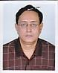 | DR. MAHMUD HASAN  F/Name: Late Abdul Hakim Khan  M/Name:  BM & DC Reg. No:  NID:  Cell:  Address: Mymenshing Medical College, Mymensingh  Blood Group:
229 | Voter No  LM-4100229  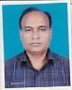 | DR. MD. MATIUR RAHMAN  F/Name: Md. Abdul Aziz  M/Name:  BM & DC Reg. No:  NID:  Cell:  Address: Registerer (Ortho)  Mymenshing Medical College  Mymensingh  Blood Group:
230 | Voter No  LM-4100230  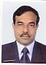 | DR. CHANDANENDU BHUSHAN SARKER  F/Name:  M/Name:  BM & DC Reg. No:  NID:  Cell:  Address: Associate Prof. Medi. Mymenshing Medical College, Mymensingh  Blood Group:
231 | Voter No  LM-4100231  No Image | DR. M. SHAMSHER ALI  F/Name:  M/Name:  BM & DC Reg. No:  NID:  Cell:  Address: RP, NICVD, Sher-E-Bangla Nagar, Dhaka.  Blood Group:
232 | Voter No  LM-4100232  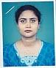 | DR. BILKIS BEGUM  F/Name:  M/Name:  BM & DC Reg. No:  NID:  Cell:  Address: 5, Zilla School Road, Mymensingh  Blood Group:
233 | Voter No  LM-4100233  No Image | DR. MD. SHARIF HUSSAIN  F/Name:  M/Name:  BM & DC Reg. No:  NID:  Cell:  Address: MO, Eye, OPD, Mymenshing Medical College, Mymensingh.  Blood Group:
234 | Voter No  LM-4100234  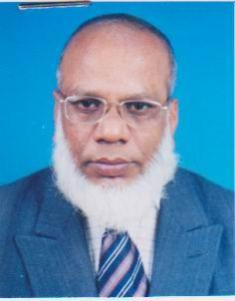 | DR. MESBAH UDDIN AHMED  F/Name:  M/Name:  BM & DC Reg. No:  NID:  Cell:  Address: Asso. Prof. Ortho. Mymenshing Medical College, Mymensingh  Blood Group:
235 | Voter No  LM-4100235  No Image | DR. SURAIYA BEGUM  F/Name:  M/Name:  BM & DC Reg. No:  NID:  Cell:  Address: 77, Sehera, Mymensingh  Blood Group:
236 | Voter No  LM-4100236  No Image | DR. KOHEREEN BASHAR  F/Name:  M/Name:  BM & DC Reg. No: 19756  NID:  Cell:  Address: NHB-29, Flat # A, Nabaneer, Govt. Officers Quarter, Khilji Road, Mohammadpur, Dhaka  Blood Group:  TRANSFERED to BMA Dhaka City  LM-1405543
237 | Voter No  LM-4100237  No Image | DR. MD. MAZIBUR RAHMAN  F/Name:  M/Name:  BM & DC Reg. No:  NID:  Cell:  Address: Asso. Prof, Surgery Dept. Mymenshing Medical College, Mymensingh  Blood Group:
238 | Voter No  LM-4100238  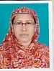 | DR. SALEHA KHATUN  F/Name:  M/Name:  BM & DC Reg. No:  NID:  Cell:  Address: Medical Officer, Gynae, Mymenshing Medical College, Mymensingh  Blood Group:
239 | Voter No  LM-4100238  No Image | DR. SALEHA KHATUN  F/Name: Kh. Sabet Ali  M/Name:  BM & DC Reg. No:  NID:  Cell:  Address: N/A  Blood Group:
240 | Voter No  LM-4100239  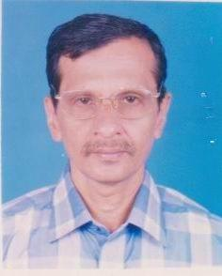 | PROF. DR. MD. MONIRUL ISLAM  F/Name:  M/Name:  BM & DC Reg. No:  NID:  Cell:  Address: Anes. Dept. Mymenshing Medical College, Mymensingh  Blood Group:
241 | Voter No  LM-4100240  No Image | DR. MD. SIRAJUL HOQUE TALUKDER  F/Name:  M/Name:  BM & DC Reg. No:  NID:  Cell:  Address: Hatua Ghate, Mymensingh  Blood Group:
242 | Voter No  LM-4100241  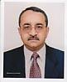 | DR. SHAHRUKH AHMED  F/Name: Jalaluddin Ahmed  M/Name:  BM & DC Reg. No: 11726  NID:  Cell:  Address: Associate Prof. Neuro Medicine, Mymenshing Medical College, Mymensingh  Blood Group:
243 | Voter No  LM-4100242  No Image | DR. AHMED MORTUGA  F/Name:  M/Name:  BM & DC Reg. No:  NID:  Cell:  Address: Asst. Prof. Child. Mymenshing Medical College, Mymensingh  Blood Group:
244 | Voter No  LM-4100243  No Image | DR. MD. FAZLUR RAHMAN CHOWDHURY  F/Name:  M/Name:  BM & DC Reg. No:  NID:  Cell:  Address: Senior Consultant Ortho. Surgery  OSD. D.G. Health,  Bangladesh Secretariat Clinic, Dhaka.  Blood Group:  TRANSFERED to BMA Dhaka City  LM-1405543
245 | Voter No  LM-4100245  No Image | DR. SAYEDA SULTANA  F/Name:  M/Name:  BM & DC Reg. No:  NID:  Cell:  Address: Asso. Prof. Pharmacology, Dept. Mymenshing Medical College, Mymensingh  Blood Group:
246 | Voter No  LM-4100246  No Image | DR. SHAMSUN NAHAR  F/Name:  M/Name:  BM & DC Reg. No:  NID:  Cell:  Address: Prof. Head of Dept. Pharmacology Dept. Mymenshing Medical College, Mymensingh  Blood Group:
247 | Voter No  LM-4100247  No Image | DR. SURAIYA YASMIN  F/Name: Mufti Heayetullah  M/Name:  BM & DC Reg. No:  NID:  Cell:  Address: Consultant, Gynae, Valuka, Mymensingh  Blood Group:
248 | Voter No  LM-4100248  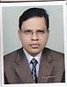 | DR. MD. AMINUL ISLAM  F/Name:  M/Name:  BM & DC Reg. No:  NID:  Cell:  Address: Register. Medicine, CBMCB, Winnerpara, Mymensingh  Blood Group:
249 | Voter No  LM-4100249  No Image | DR. A.K.M. HAFIZUDDIN KHAN  F/Name: Md. Mafiz Uddin Khan  M/Name:  BM & DC Reg. No:  NID:  Cell:  Address: Sr. Store Officer, MMCH, Mymensingh  Blood Group:
250 | Voter No  LM-4100250  No Image | DR. MD. GHULAM RABBANI  F/Name: Tofail Ahmed  M/Name:  BM & DC Reg. No:  NID:  Cell:  Address: 19/A, Brahma Polli, MMCH, Mymensingh  Blood Group:
251 | Voter No  LM-4100251  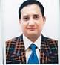 | DR. ZIAUL MORSHED  F/Name: Late Akbar Ali Mia  M/Name:  BM & DC Reg. No:  NID:  Cell:  Address: RS, ENT, MMCH, Mymensingh  Blood Group:
252 | Voter No  LM-4100252  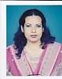 | DR. DELU ARA PARVEEN DOLLY  F/Name: Md. Abdul Hye  M/Name:  BM & DC Reg. No:  NID:  Cell:  Address: Medical Officer, Trasfusion Medicine Dept. MMCH, Mymensingh  Blood Group:
253 | Voter No  LM-4100253  No Image | DR. MD. ABDUL JABBAR  F/Name: Late Ali Azam  M/Name:  BM & DC Reg. No:  NID:  Cell:  Address: 9, Harikishore Roy Road, Mymensingh  Blood Group:
254 | Voter No  LM-4100254  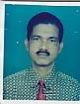 | DR. MD. MASUD KARIM  F/Name: Late Md. Kubed Ali Sarker  M/Name:  BM & DC Reg. No:  NID:  Cell:  Address: 73, Fulbaria Road, Akua Haji Bari, Mymensingh  Blood Group:
255 | Voter No  LM-4100255  No Image | DR. MD. NAZRUL ISLAM  F/Name: Md. Eunus Ali  M/Name:  BM & DC Reg. No:  NID:  Cell:  Address: Bazlunnahar Mansion, Akua Moralpara, Mymensingh  Blood Group:
256 | Voter No  LM-4100256  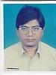 | DR. MADHAB CHANDRA SEN  F/Name: Late Sunil Chandra  M/Name:  BM & DC Reg. No:  NID:  Cell:  Address: EMO, MMCH, Mymensingh  Blood Group:
257 | Voter No  LM-4100257  No Image | DR. TITU MIAH  F/Name:  M/Name:  BM & DC Reg. No:  NID:  Cell:  Address: TRANSFERED to BMA Dhaka City. LM-1404040.  Blood Group:  TRANSFERED to BMA Dhaka City  LM-1405543
258 | Voter No  LM-4100258  No Image | DR. MOHAMMAD ANWAR HUSSAIN  F/Name: Md. Mokbul Hossain  M/Name:  BM & DC Reg. No:  NID:  Cell:  Address: 12, Shyma Charan Roy Road, Mymensingh  Blood Group:
259 | Voter No  LM-4100259 | DR. MD. NAZMUL ALAM KHAN  F/Name: Md. Mazibur Rahman Khan  M/Name:  BM & DC Reg. No:  NID:  Cell:  Address: 76/3-3, Baghmara, Brahmapalli Road, Mymensingh  Blood Group:
260 | Voter No  LM-4100260  No Image | DR. MD. ASADOZZAMAN  F/Name: Md. Faizuddin Sarker  M/Name:  BM & DC Reg. No:  NID:  Cell:  Address: Asst. Reg. Skin & VD, MMCH, Mymensingh  Blood Group:
261 | Voter No  LM-4100261  No Image | DR. MD. SHAMSUL HAQUE  F/Name: Late Md. Siddiqur Rahman  M/Name:  BM & DC Reg. No:  NID:  Cell:  Address: 3/13, Charpara Medical Staff Quarter, Mymensingh  Blood Group:
262 | Voter No  LM-4100262  No Image | DR. MD. SHAMSUZZAMAN  F/Name: Late Md. Abdur Razzaque  M/Name:  BM & DC Reg. No:  NID:  Cell:  Address: Asst. Prof. Cardiology, MMCH, Mymensingh  Blood Group:
263 | Voter No  LM-4100263  No Image | DR. SYED NASIR UDDIN  F/Name: Syed Ali Ashrab  M/Name:  BM & DC Reg. No:  NID:  Cell:  Address: Dept. of Cardiolgy, MMCH, Mymensingh  Blood Group:
264 | Voter No  LM-4100264  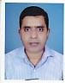 | DR. KHANDKER MAHBUBAR RAHMAN  F/Name: Late KH. Maminur Rahman  M/Name:  BM & DC Reg. No:  NID:  Cell:  Address: 4/C, Medical Staff Quarter, Charpara, Mymensingh  Blood Group:
265 | Voter No  LM-4100265  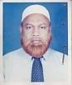 | DR. SAMPAD NARAYAN DEY  F/Name: Tarini Prasanna Dey  M/Name:  BM & DC Reg. No:  NID:  Cell:  Address: 29/Cha, Madan Babu Road, Mymensingh  Blood Group:
266 | Voter No  LM-4100266  No Image | DR. MD. AKTERUZZAMAN TALUKDER  F/Name: Haider Ali Talukder  M/Name:  BM & DC Reg. No:  NID:  Cell:  Address: Asst. Prof. Forensic Medicine, Mymensingh  Blood Group:
267 | Voter No  LM-4100267  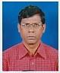 | DR. MD. CHAND MAHMUD  F/Name: Md. Mafiz Uddin  M/Name:  BM & DC Reg. No:  NID:  Cell:  Address: 9, Firoza Manzil, Omedali Road, Mymensingh  Blood Group:
268 | Voter No  LM-4100268  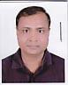 | DR. ABUL KHAIR MD. SHAMSUZZAMAN  F/Name: Late Amzad Hossain Chowdhury  M/Name:  BM & DC Reg. No:  NID:  Cell:  Address: 54/1, Gulkibari Road, Mymensingh  Blood Group:  E X P I R E D
269 | Voter No  LM-4100269  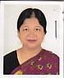 | DR. SHAMIMA AKHTER  F/Name: Md. Mojibur Rahman  M/Name:  BM & DC Reg. No:  NID:  Cell:  Address: 54/1, Gulkibari Road, Mymensingh  Blood Group:
270 | Voter No  LM-4100270  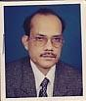 | DR. MD. LABIUL HARUN  F/Name: Md. Kazemuddin Ahmed  M/Name:  BM & DC Reg. No:  NID:  Cell:  Address: Associate Professor Medicine, Mymensingh Medical College, Mymensingh.  Blood Group:
271 | Voter No  LM-4100271  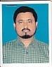 | DR. MD. WAIZUDDIN FARAJI  F/Name: Late Abhdul Jabber Faraji  M/Name:  BM & DC Reg. No:  NID:  Cell:  Address: RMO, Upazilla Health Complex, Haluaghat, Mymensingh  Blood Group:
272 | Voter No  LM-4100272  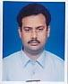 | DR. MD. SHAFIQUR RAHMAN  F/Name: Md. Habibur Rahman  M/Name:  BM & DC Reg. No:  NID:  Cell:  Address: Jr. Consultant, UHC Muktagacha, Mymensingh  Blood Group:
273 | Voter No  LM-4100273  No Image | DR. MUHAMMAD ILYAS  F/Name: Md. Hashemuddin  M/Name:  BM & DC Reg. No:  NID:  Cell:  Address: Civil Surgeon Quarter, Mymensingh  Blood Group:
274 | Voter No  LM-4100274  No Image | DR. MD. MOKARABIN ROBIN  F/Name: Late Md. Hasan Uddin  M/Name:  BM & DC Reg. No:  NID:  Cell:  Address: Anatomy Dept. MMCH Mymensingh  Blood Group:
275 | Voter No  LM-4100275  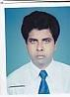 | DR. NOOR MD. SHAMSUL ALAM  F/Name: Md. Umed Ali  M/Name:  BM & DC Reg. No:  NID:  Cell:  Address: 58/1, Baghmara Road (Ground Floor), Mymensingh  Blood Group:
276 | Voter No  LM-4100276  No Image | DR. MD. RAFIQUL ISLAM  F/Name: Late Md. Harunor Rashid  M/Name:  BM & DC Reg. No:  NID:  Cell:  Address: 2,G.C. Road, Mymensingh  Blood Group:
277 | Voter No  LM-4100277  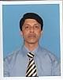 | DR. M. A. M. SHAKHAWAT HOSSAIN KHAN  F/Name: Late. Akther Hossain Khan  M/Name: Mrs. Saleha Khanom  BM & DC Reg. No: 12208  NID: 6125212136940  Cell: 01711623145  Address: 2/1, Chotris bari lane,Akua Chowrangi Moor,Maymanshing  Blood Group: A+
278 | Voter No  LM-4100278  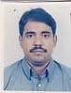 | DR. IZAZ AHMED KHAN  F/Name: Md. Ibrahim Khan  M/Name:  BM & DC Reg. No:  NID:  Cell:  Address: 6, Mrituyanjoy School Road, Mymensingh  Blood Group:
279 | Voter No  LM-4100279  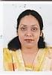 | DR. RIFFAT RAHIM  F/Name: S.A. Rahim  M/Name:  BM & DC Reg. No:  NID:  Cell:  Address: 6, Mrituyanjoy School Road, Mymensingh  Blood Group:
280 | Voter No  LM-4100280  No Image | DR. MD. HEFZUL BARI  F/Name: Md. Syeduzzaman  M/Name:  BM & DC Reg. No:  NID:  Cell:  Address: Jr. Consultant, Anesthesia, MMCH, Mymensingh  Blood Group:
281 | Voter No  LM-4100281  No Image | DR. MOHAMMAD ALI (SHAHEEN)  F/Name: Md. Aftab Uddin  M/Name:  BM & DC Reg. No:  NID:  Cell:  Address: 13, Charpara, Mymensingh  Blood Group:
282 | Voter No  LM-4100282  No Image | DR. MD. MOZAFFAR HOSSAIN TALUKDER  F/Name: Md. Jamal Uddin Talukder  M/Name:  BM & DC Reg. No:  NID:  Cell:  Address: Anesthesiologist, MMCH, Mymensingh  Blood Group:
283 | Voter No  LM-4100283  No Image | DR. MD. FARHAD HUSAIN  F/Name: Late Md. Mofiz Uddin  M/Name:  BM & DC Reg. No:  NID:  Cell:  Address: Medical Officer, Inshwargani UHC, Mymensingh  Blood Group:
284 | Voter No  LM-4100284  No Image | DR. LAKSHMI NARAYAN MAJUMDER  F/Name: Late Jatindra Mohan Majumder  M/Name:  BM & DC Reg. No:  NID:  Cell:  Address: Medical Officer, Iswargonj UHC, Mymensingh  Blood Group:
285 | Voter No  LM-4100285  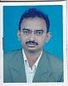 | DR. MD. GOLAM MOSTAFA  F/Name: Md. Belat Ali  M/Name:  BM & DC Reg. No:  NID:  Cell:  Address: New Medicare, Diagnostic Complex, Chorpara, Mymensingh  Blood Group:
286 | Voter No  LM-4100286  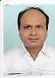 | DR. MD. SHAFIQUL ISLAM  F/Name: Md. Gias Uddin  M/Name:  BM & DC Reg. No:  NID:  Cell:  Address: Upazila Health Complex, Trisal, Mymensingh  Blood Group:
287 | Voter No  LM-4100287  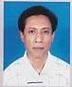 | DR. MD. AMINUL HAQUE  F/Name: Md. Sirajul Haque  M/Name:  BM & DC Reg. No:  NID:  Cell:  Address: 60/4, Mashkanda, Mymensingh  Blood Group:
288 | Voter No  LM-4100288  No Image | DR. MUHAMMED ALAM  F/Name: Mohammed Abdul Majid  M/Name:  BM & DC Reg. No:  NID:  Cell:  Address: 170, Kalibari Road, Mymensingh  Blood Group:
289 | Voter No  LM-4100289  No Image | DR. BIBI ZAINAB  F/Name: Mohammed Abdul Majid  M/Name:  BM & DC Reg. No:  NID:  Cell:  Address: 170, Kalibari Road, Mymensingh  Blood Group:
290 | Voter No  LM-4100290  No Image | DR. FAYELA SABRUN SIDDIQUEE  F/Name: AKM. Fazlur Rahman Siddiquee  M/Name:  BM & DC Reg. No:  NID:  Cell:  Address: 94, Charpara, Mymensingh  Blood Group:
291 | Voter No  LM-4100291 | DR. SULTAN AHMED  F/Name: Abdur Rahman  M/Name:  BM & DC Reg. No:  NID:  Cell:  Address: Farida Manjheel, Hospital Road, Gafargaon, Mymensingh  Blood Group:
292 | Voter No  LM-4100292  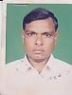 | DR. MD. NURUL HAQUE  F/Name: Late Mvi. Shriatullah  M/Name:  BM & DC Reg. No:  NID:  Cell:  Address: Medical Officer, Upazilla Health Complex, Gafargaon, Mymensingh  Blood Group:
293 | Voter No  LM-4100293  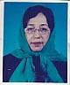 | DR. H.A. MAHMUDUNESSA  F/Name: Md. Momtazuddin Ahmed  M/Name:  BM & DC Reg. No:  NID:  Cell:  Address: UH&FPO, UHC Muktagacha, Mymensingh  Blood Group:
294 | Voter No  LM-4100294  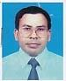 | DR. SAMARESH CHANDRA KUNDU  F/Name: Baba Kamal Kanta Kundu  M/Name:  BM & DC Reg. No:  NID:  Cell:  Address: Asst. Prof, ENT, Mymensingh Medical Hospital, Mymensingh.  Blood Group:
295 | Voter No  LM-4100295  No Image | DR. AFM. KAMRUZZAMAN  F/Name: A. Hamid  M/Name:  BM & DC Reg. No:  NID:  Cell:  Address: Medical Officer, Upazila Health Complex Gafargaon, Mymensingh  Blood Group:
296 | Voter No  LM-4100296  No Image | DR. MD. AYUB ALI CHOWDHURY  F/Name: Late Badiul Alam Chowdhury  M/Name:  BM & DC Reg. No:  NID:  Cell:  Address: Flat-B2, Daffodil Tower, House-22 Road-28(Old), 15(New) Dhanmondi, Dhaka  Blood Group:
297 | Voter No  LM-4100297  No Image | DR. JAHANGIR MD. SARWAR  F/Name: Md. Shahjahan Mia  M/Name:  BM & DC Reg. No:  NID:  Cell:  Address: Chandra, 5/C, Medical Staff Quater. Charpara, Mymensingh  Blood Group:
298 | Voter No  LM-4100298  No Image | DR. SM. MOINUL ISLAM  F/Name: Md. Abdur Rahman  M/Name:  BM & DC Reg. No:  NID:  Cell:  Address: Mymensingh  Blood Group:
299 | Voter No  LM-4100299  No Image | DR. SAIYEEDA MAHMOOD  F/Name: Muhammad Ullah  M/Name:  BM & DC Reg. No:  NID:  Cell:  Address: Centre for Nuclear Medicine & Ultrasound and Ultrasono, Mymensingh  Blood Group:
300 | Voter No  LM-4100300  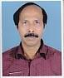 | DR. MD. MATIUR RAHMAN BHUIYAN  F/Name: Late Asir Uddin Bhuiyan  M/Name:  BM & DC Reg. No:  NID:  Cell:  Address: 58/1, Baghmara Road (Ground Floor), Mymensingh  Blood Group:
301 | Voter No  LM-4100301  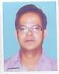 | DR. KANCHAN SARKER  F/Name: Khagendra Ch Sarker  M/Name:  BM & DC Reg. No:  NID:  Cell:  Address: 30, J.C. Guha Road, Mymensingh  Blood Group:
302 | Voter No  LM-4100302  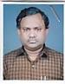 | DR. MD. SELIM DAD  F/Name: Late Md. Khoda Dad  M/Name:  BM & DC Reg. No:  NID:  Cell:  Address: 38/A/4, Shankipara, Mymensingh  Blood Group:
303 | Voter No  LM-4100303  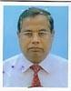 | DR. MD. SAIDUL AMIN  F/Name: Late Ismat Ali  M/Name:  BM & DC Reg. No:  NID:  Cell:  Address: 2, Gulkibari By Lane, Aloknanda, Mymensingh  Blood Group:
304 | Voter No  LM-4100304  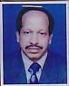 | DR. MADAN GOPAL DATTA  F/Name: Late Bhupendra Chandra Datta  M/Name:  BM & DC Reg. No:  NID:  Cell:  Address: 170, Kalibari Road, Sakib Villa, Mymensingh  Blood Group:
305 | Voter No  LM-4100305  No Image | DR. MD. ABDUL BARI  F/Name: Md. Abdul Hai  M/Name:  BM & DC Reg. No:  NID:  Cell:  Address: 29C, RK. Mission Road, Mymensingh  Blood Group:
306 | Voter No  LM-4100306  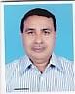 | DR. MRINAL KANTI ROY  F/Name: Manindra Chandra Roy  M/Name:  BM & DC Reg. No:  NID:  Cell:  Address: 6, Mritywnjoy School Road, Mymensingh  Blood Group:
307 | Voter No  LM-4100307  No Image | DR. MD. SHARIFUL ALAM KHAN  F/Name: Nur Mohammad Khan  M/Name:  BM & DC Reg. No:  NID:  Cell:  Address: A/R, Surgery, Unit-1, MMCH, Mymensingh  Blood Group:
308 | Voter No  LM-4100308  No Image | DR. NIMAI CHANDRA MANDAL  F/Name: Late Jyotish Ch. Mandal  M/Name:  BM & DC Reg. No:  NID:  Cell:  Address: Asst. Director, MMCH, Mymensingh  Blood Group:
309 | Voter No  LM-4100309  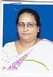 | DR. MINATI BANERJEE  F/Name: Late Madhusudan Banerjee  M/Name:  BM & DC Reg. No:  NID:  Cell:  Address: Biochemistry Dept. MMCH, Mymensingh  Blood Group:
310 | Voter No  LM-4100310  No Image | DR. MUHAMMAD ABUL FATHA  F/Name: Muhammad Solaiman  M/Name:  BM & DC Reg. No:  NID:  Cell:  Address: Asst. Prof. Biochemistry, Mymensingh Medical College, Mymensingh.  Blood Group:
311 | Voter No  LM-4100311  No Image | DR. MD. RUHUL AMIN KHAN  F/Name: Late Md. Abdul Mannaf Khan  M/Name:  BM & DC Reg. No:  NID:  Cell:  Address: 25/2, Sehora, Mymensingh  Blood Group:
312 | Voter No  LM-4100312  No Image | DR. MD. GOLAM MOHIUDDIN  F/Name:  M/Name:  BM & DC Reg. No:  NID:  Cell:  Address: Tranesfered to Dhaka City, LM-1402846.  Blood Group:  TRANSFERED to BMA Dhaka City  LM-1405543
313 | Voter No  LM-4100313  No Image | DR. MOHAMMAD ALLAMA IQBAL  F/Name: Mohammad Ibrahim  M/Name:  BM & DC Reg. No:  NID:  Cell:  Address: 63/1, Hamiduddin Road, Sadar, Mymensingh  Blood Group:
314 | Voter No  LM-4100314  No Image | DR. SYEED MEHBUB UL KADIR  F/Name:  M/Name:  BM & DC Reg. No:  NID:  Cell:  Address: TRANSFERED to BMA Dhaka City, LM-1404041.  Blood Group:  TRANSFERED to BMA Dhaka City  LM-1405543
315 | Voter No  LM-4100315 | DR. MURSHED ALAM  F/Name: Md. Khabir Uddin  M/Name:  BM & DC Reg. No:  NID:  Cell:  Address: 323, Charpara Moor, Kotwali, Mymensingh  Blood Group:
316 | Voter No  LM-4100316  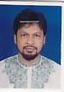 | DR. MD. ASADUZZAMAN RAZA  F/Name: Md. Abdul Bari  M/Name:  BM & DC Reg. No:  NID:  Cell:  Address: 3, R.K. Mission Road, Sehora, Mymensingh  Blood Group:
317 | Voter No  LM-4100317  No Image | DR. MD. ZAKIR HOSSAIN ZIKO  F/Name: Md. Fazlul Haque  M/Name:  BM & DC Reg. No:  NID:  Cell:  Address: 11/A, Staff Quarter, MMCH, Mymensingh  Blood Group:
318 | Voter No  LM-4100318  No Image | DR. A.K.M. SADEQUL ISLAM  F/Name: Late Abu Sayeed  M/Name:  BM & DC Reg. No:  NID:  Cell:  Address: 11, Aqua Lichu Bagan, Mymensingh  Blood Group:
319 | Voter No  LM-4100319  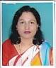 | DR. SHILA SEN  F/Name: Late Promod Ch. Sen  M/Name:  BM & DC Reg. No:  NID:  Cell:  Address: 27, Congress Jubili Road, Mymensingh  Blood Group:
320 | Voter No  LM-4100320  No Image | DR. MD. JAHANGIR ALAM  F/Name: Md. Abul Hashem Mia  M/Name:  BM & DC Reg. No:  NID:  Cell:  Address: Health Complex Charpara, Mymensingh  Blood Group:
321 | Voter No  LM-4100321  No Image | DR. GANA PATI ADITTA  F/Name: Late Marityunjoy Aditya  M/Name:  BM & DC Reg. No:  NID:  Cell:  Address: 2, Monmohan Niyogi Road, Panditpara, Mymensingh  Blood Group:
322 | Voter No  LM-4100322  No Image | DR. LAKSHMAN CHANDRA BALO  F/Name: Late Fakir Chand Balo  M/Name: Late Feli Rani Balo  BM & DC Reg. No: A-15788  NID:  Cell:  Address: 250 Beded District Hospital, Manikganj-1800, Bangladesh.  Blood Group:
323 | Voter No  LM-4100323  No Image | DR. MURSHID UDDIN  F/Name: Late Elias Uddin  M/Name:  BM & DC Reg. No:  NID:  Cell:  Address: 43, A. Bagh Mara Road, Mymensingh  Blood Group:
324 | Voter No  LM-4100324  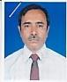 | DR. JOTHSNA MAHBUB KHAN  F/Name: Md. Akkas Ali  M/Name:  BM & DC Reg. No:  NID:  Cell:  Address: Hasan Diagnostic Complex Cum Outdoor Clinic, Mymensingh  Blood Group:
325 | Voter No  LM-4100325  No Image | DR. MOHAMMED ISHAQUE  F/Name: Md. Abdul Guffer  M/Name:  BM & DC Reg. No:  NID:  Cell:  Address: 70/C, Baghmara Road, Mymensingh  Blood Group:
326 | Voter No  LM-4100326  No Image | DR. MD. ISHA KHAN RAJ  F/Name: Late Mehdi Khan  M/Name:  BM & DC Reg. No:  NID:  Cell:  Address: Medhdi Khan Bhabon-28, Shehora Road, Mymensingh  Blood Group:
327 | Voter No  LM-4100327  No Image | DR. SHALEHA BEGUM  F/Name: Late Abdul Jalil  M/Name:  BM & DC Reg. No:  NID:  Cell:  Address: Medhi Khan Bhabon-28, Shehora Road, Mymensingh  Blood Group:
328 | Voter No  LM-4100328  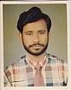 | DR. MOHAMMAD HABIBULLAH  F/Name: Sofir Uddin Ahmed  M/Name:  BM & DC Reg. No:  NID:  Cell:  Address: 115, R.K. Mission Road, Mymensingh  Blood Group:
329 | Voter No  LM-4100329  No Image | DR. KAJAL KANTI CHOWDHURY  F/Name: Dr. Jogendra Chandra Chowdhury  M/Name:  BM & DC Reg. No:  NID:  Cell:  Address: 310, Maskanda, Mymensingh  Blood Group:
330 | Voter No  LM-4100330  No Image | DR. ALI REZA SIDDIQUEE SHAHIN  F/Name: Md. Subed Ali  M/Name:  BM & DC Reg. No:  NID:  Cell:  Address: 4/1, Maskanda, Mymensingh  Blood Group:
331 | Voter No  LM-4100331  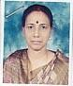 | DR. DASS RICKTA  F/Name: Upendra Chandra Das  M/Name:  BM & DC Reg. No:  NID:  Cell:  Address: Dept. of Anesthesiology, MMCH, Mymensingh  Blood Group:
332 | Voter No  LM-4100332  No Image | DR. MONUJ KUMAR ROY  F/Name: Gopal Roy  M/Name:  BM & DC Reg. No:  NID:  Cell:  Address: 267, Charpara, Mymensingh  Blood Group:
333 | Voter No  LM-4100333  No Image | DR. JAHIRUL HAQUE  F/Name: Md. Nurul Islam  M/Name:  BM & DC Reg. No:  NID:  Cell:  Address: Central Hospital, 267, Charpara, Mymensingh  Blood Group:
334 | Voter No  LM-4100334  No Image | DR. MD. ASHRAF UDDIN  F/Name: Late Md. Lokman Ali  M/Name:  BM & DC Reg. No:  NID:  Cell:  Address: Upazila Health Complex, Phulpur, Mymensingh  Blood Group:
335 | Voter No  LM-4100335  No Image | DR. SHAMIM ARA BEGUM  F/Name: Akm. Amanat Ulla  M/Name:  BM & DC Reg. No:  NID:  Cell:  Address: Modern Pathology, Charpara, Mymensingh  Blood Group:
336 | Voter No  LM-4100336  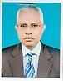 | DR. SHAH ABDUL LATIF  F/Name: Late Shah Abdul Khan  M/Name:  BM & DC Reg. No:  NID:  Cell:  Address: Prof. of Physiology, MMCH, Mymensingh  Blood Group:
337 | Voter No  LM-4100337  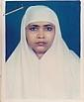 | DR. HALIMA YASMIN  F/Name: Md. Raihan Ali  M/Name:  BM & DC Reg. No:  NID:  Cell:  Address: House-15/4, R/A, B.A.U. Mymensingh  Blood Group:
338 | Voter No  LM-4100338  No Image | DR. PARVEZ SHAMS  F/Name: Late Shamsuddin Ahmed  M/Name:  BM & DC Reg. No:  NID:  Cell:  Address: Nur Mohol, 5, Shankipara, Mymensingh  Blood Group:
339 | Voter No  LM-4100339  No Image | DR. KHALEDA AKTER  F/Name: Md. Mofiz Uddin Khan  M/Name:  BM & DC Reg. No:  NID:  Cell:  Address: Nur Mahal, 5, Shankipara, Mymensingh  Blood Group:
340 | Voter No  LM-4100340  No Image | DR. A.T.M. SAZZAD HOSSAIN  F/Name: Md. Abdus Samad  M/Name:  BM & DC Reg. No:  NID:  Cell:  Address: Tohura Monzil, 78, Shehora Road, Mymensingh  Blood Group:
341 | Voter No  LM-4100341  No Image | DR. A.S.M. FAZLULLAH  F/Name: Late Md. Hussain  M/Name:  BM & DC Reg. No:  NID:  Cell:  Address: 138/C, R.K. Mission Road, Noumahal, Mymensingh  Blood Group:
342 | Voter No  LM-4100342  No Image | DR. MD. GOLAM AZAM.  F/Name:  M/Name:  BM & DC Reg. No:  NID:  Cell:  Address: TRANSFERED to BMA Rangpur Branch, LM-134.  Blood Group:  TRANSFERED to BMA Dhaka City  LM-1405543
343 | Voter No  LM-4100343 | DR. A.B.M. MAQSUDUS SALEHIN  F/Name: Late Dr. Mohammad Ali  M/Name:  BM & DC Reg. No:  NID:  Cell:  Address: Ali Reza Eye Clinic, 25/A, Sehora, Mymensingh  Blood Group:  E X P I R E D
344 | Voter No  LM-4100344  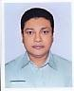 | DR. ABM. MAQSUDUL HAQUE NAYAN  F/Name: Late Dr. Mohammad Ali  M/Name:  BM & DC Reg. No:  NID:  Cell:  Address: 14, Umed Ali Road, Sehora, Mymensingh  Blood Group:
345 | Voter No  LM-4100345  No Image | DR. MUJIBUR RAHMAN  F/Name: Late Md. Habibur Rahman  M/Name:  BM & DC Reg. No:  NID:  Cell:  Address: Upazilla Health Complex, Bhaluka. Mymensingh  Blood Group:
346 | Voter No  LM-4100346  No Image | DR. SHAHINUR SULTANA  F/Name: M. Lutfar Rahman  M/Name:  BM & DC Reg. No:  NID:  Cell:  Address: Lecturer Dept. of Anatomy, CBMC,B, Mymensingh  Blood Group:
347 | Voter No  LM-4100347  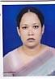 | DR. SEHELI ZANNAT SULTANA  F/Name: A.a.m. Abdush Sakur  M/Name:  BM & DC Reg. No:  NID:  Cell:  Address: Mphi. Anatomy, MMCH, Mymensingh  Blood Group:
348 | Voter No  LM-4100348  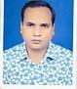 | DR. ZAKIR HOSSAIN KHAN  F/Name: Late Mokshed Hossain Khan  M/Name:  BM & DC Reg. No:  NID:  Cell:  Address: CBMC B Mymensingh  Blood Group:
349 | Voter No  LM-4100349  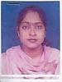 | DR. NAHID BINTAY ANSARY  F/Name: Md. Lutfor Rahman Ansary  M/Name:  BM & DC Reg. No:  NID:  Cell:  Address: CBMC B Mymensingh  Blood Group:
350 | Voter No  LM-4100350  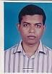 | DR. MOHAMMAD ABDULLAH AL MAMUN  F/Name: Abul Bashar Mohd. Shahidullah  M/Name:  BM & DC Reg. No:  NID:  Cell:  Address: House-3/4, Telephone House Staff Qrt, Mymensingh  Blood Group:
351 | Voter No  LM-4100351  No Image | DR. SULTAN FAZLEY RABBI (NAHID)  F/Name: Dr. Md. Nasir Uddin  M/Name:  BM & DC Reg. No:  NID:  Cell:  Address: Nahid Villa, Nasirabad College Road, Akua, Mymensingh  Blood Group:
352 | Voter No  LM-4100352  No Image | DR. SULTANA RABEYA  F/Name: Dr. Md. Nasir Uddin  M/Name:  BM & DC Reg. No:  NID:  Cell:  Address: Nahid Villa, Nasirabad College Road, Akua, Mymensingh  Blood Group:
353 | Voter No  LM-4100353  No Image | DR. ABDULLAH AL NOMAN  F/Name: Md. Abdul Ghani  M/Name:  BM & DC Reg. No:  NID:  Cell:  Address: 306/26, Amirabad Housing, Maskanda, Mymensingh  Blood Group:
354 | Voter No  LM-4100354  No Image | DR. MOSTOFA ZAHID KAMAL BIPU  F/Name: Md. Kamal Uddin  M/Name:  BM & DC Reg. No:  NID:  Cell:  Address: Registrar Surgery, MMCH, Mymensingh  Blood Group:
355 | Voter No  LM-4100355  No Image | DR. MOHAMMAD SHAFIQUR RAHMAN  F/Name: Md. Mostafizur Rahman  M/Name:  BM & DC Reg. No:  NID:  Cell:  Address: 146, Shenbari Road, Mymensingh  Blood Group:
356 | Voter No  LM-4100356  No Image | DR. MD. RAJIBUL HASAN  F/Name: Mohammad Abdus Sahid  M/Name:  BM & DC Reg. No:  NID:  Cell:  Address: Kheyatory, 8, Chaarpara, Mymensingh  Blood Group:
357 | Voter No  LM-4100357 | DR. A.H.M. HASAN  F/Name: Dr. Abdur Rashid Taluckder  M/Name:  BM & DC Reg. No:  NID:  Cell:  Address: 33, R.K. Mission Road, Mymensingh  Blood Group:
358 | Voter No  LM-4100358  No Image | DR. RAFIA SHAMEEM  F/Name: Md. Naem Uddin  M/Name:  BM & DC Reg. No:  NID:  Cell:  Address: 118-B, Riad Villa, Aqua, Firoj Library More, Mymensingh  Blood Group:
359 | Voter No  LM-4100359  No Image | DR. MD. NASIR UDDIN  F/Name: Md. Kashem Ali  M/Name:  BM & DC Reg. No:  NID:  Cell:  Address: 25, Akua Uttar Para, Akua Chourangi Moor, Mymensingh  Blood Group:
360 | Voter No  LM-4100360  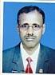 | DR. MD. SHAHIDULLAH  F/Name: Md. Habibullah  M/Name:  BM & DC Reg. No:  NID:  Cell:  Address: Associate Prof. Community Medicine, CBMC,B, Mymensingh  Blood Group:
361 | Voter No  LM-4100361  No Image | DR. JALAL UDDIN AHMED  F/Name: Mohammad Eunus  M/Name:  BM & DC Reg. No:  NID:  Cell:  Address: Biochemistry Dept. CBMC,B, Winner Para, Mymensingh  Blood Group:
362 | Voter No  LM-4100362  No Image | DR. K.A.R. SAYEED  F/Name: Mohammad Azizullah  M/Name:  BM & DC Reg. No:  NID:  Cell:  Address: Pathology Dept. CBMC,B, Mymensingh  Blood Group:
363 | Voter No  LM-4100363  No Image | DR. FARIDA YESMIN  F/Name: Anowar Hossain  M/Name:  BM & DC Reg. No:  NID:  Cell:  Address: Community Based Medical College, Mymensingh  Blood Group:  E X P I R E D
364 | Voter No  LM-4100364  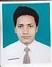 | DR. MD. MUKTI MAHAMUD  F/Name: Md. Shahjahan Khan  M/Name:  BM & DC Reg. No:  NID:  Cell:  Address: 187/C, R.K. Mission Road, Mymensingh  Blood Group:
365 | Voter No  LM-4100365 | DR. FATEMA WAHED  F/Name: Abdul Wahed Talukder  M/Name:  BM & DC Reg. No:  NID:  Cell:  Address: 187/C, R.K. Mission Road, Mymensingh  Blood Group:
366 | Voter No  LM-4100366  No Image | DR. MD. NURUL ISLAM AKANDA  F/Name: Md. Mofizuddin Akanda  M/Name:  BM & DC Reg. No: 13018  NID:  Cell:  Address: Mymensingh Medical College, Mymensingh  Blood Group:
367 | Voter No  LM-4100367 | DR. A. F. M. RAFIQUL ALAM  F/Name: Md. Makbul Hossain  M/Name: Mst. Rabeya Khatoon  BM & DC Reg. No: 13071  NID: 8926709471544  Cell: 01711678338  Address: Senior Store officer, Mymenshingh Medical College hospital  Blood Group: O+
368 | Voter No  LM-4100368  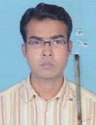 | DR. DEBASH MONDAL  F/Name: Rabindra Nath Mondal  M/Name: Raju Bala Mondol  BM & DC Reg. No: 38858  NID:  Cell: 01722066444  Address: 37/1, siraj Manshan (2nd Floor), Bhrammopolly By lane , Mymensing  Blood Group: O+
369 | Voter No  LM-4100369  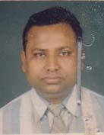 | DR. PANKAJ KUMAR DAS  F/Name: Late. Anil Chandra Das  M/Name: Basanti Das  BM & DC Reg. No: 21896  NID: 6216503810991  Cell: 01715813772  Address: Suniti Nibash, College Road, Barahissa Bazar, Muktagacha , Mymensing  Blood Group: A+
370 | Voter No  LM-4100370  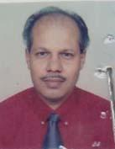 | DR. KRISHAN CHANDRA GANGULY  F/Name: Bhupendra Nath Ganguly  M/Name: Renuka Ganguly  BM & DC Reg. No: 14381  NID: 6125210177039  Cell: 01711110560  Address: 44- C/1 Daulat Munshi Bi lane ,Krishtopur , Mymenshing-2200  Blood Group: O+
371 | Voter No  LM-4100371  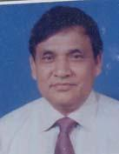 | DR. MD. HUMAYUN KABIR  F/Name: Late. Md. Oubadul Haque Sarker  M/Name: Late. Mst. Nurun Nahar  BM & DC Reg. No: 31473  NID: 6215205134274  Cell: 01711624824  Address: Ortho Surgery, 53/Ka, Shanki Para Mymensing  Blood Group: O+  E X P I R E D
372 | Voter No  LM-4100372  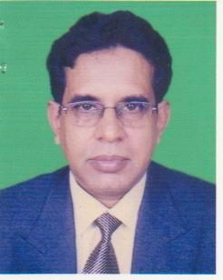 | DR. TRIDIB KANTI BISWAS  F/Name: Late Akhil Chandra Biswas  M/Name:  BM & DC Reg. No:  NID:  Cell:  Address: Anesthesiologist, 69/3, Sarada Ghosh Road, Mymensingh  Blood Group:
373 | Voter No  LM-4100373  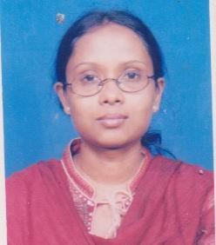 | DR. TAHMINA SHARMIN  F/Name: Gulam Mowla  M/Name:  BM & DC Reg. No:  NID:  Cell:  Address: Kheyatory 8 Charpara, Mymensingh  Blood Group:
374 | Voter No  LM-4100374  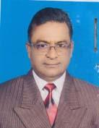 | DR. A. F. M. HEFZUL BARI KHAN  F/Name: Abdul Bari Khan  M/Name: Late. Fatema Khatun  BM & DC Reg. No: 18547  NID: 8928807142412  Cell: 01718062320  Address: Assistant Registrar (Psychiatry), Mymensingh.  Blood Group: O+
375 | Voter No  LM-4100375  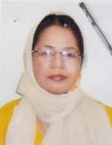 | DR. AFROZA BEGUM  F/Name: Naim Uddin Ahmed  M/Name: Mrs. Rabeya Begum  BM & DC Reg. No: 13573  NID: 6125219247912  Cell: 01715938435  Address: Gynae & Obs. Bhatikasor, Alia Madrasha Road, Mymensingh  Blood Group: B+
376 | Voter No  LM-4100376  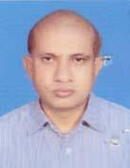 | DR. RAKHAL CHANDRA DEBNATH  F/Name: Toroni Kantu Deb Nath  M/Name: Pushpoo Rani Deb Nath  BM & DC Reg. No: 18123  NID: 6125207155723  Cell: 01712114496  Address: DTCD, MD(Cardiology), 17 No. Kali Sankar Guho Road (Pandit Bari), Protima Kutir, Mymensingh.  Blood Group: O+
377 | Voter No  LM-4100377  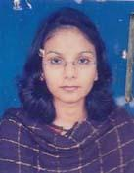 | DR. MAHZABEEN ISLAM  F/Name: Prof. Nazrul Islam  M/Name: Momtaz Begum  BM & DC Reg. No: 40558  NID: 2650898261314  Cell: 01196086858  Address: Radiology & Imaging, 6/3 Power House Road, Kewatkhali, Mymensingh  Blood Group: A+
378 | Voter No  LM-4100378  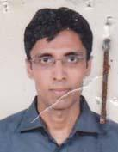 | DR. EHSANUR REZA  F/Name: Abdur Razzaque  M/Name: Rawshan Ara Begum  BM & DC Reg. No: 30252  NID: 2697557397824  Cell: 01191123994  Address: General Surgery, 6/3 Power House Road, Kewatkhali, Mymensingh  Blood Group: A+
379 | Voter No  LM-4100379  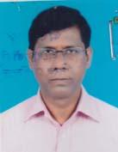 | DR. MD. CHAND MAHMUD  F/Name: Md. Mafiz Uddin  M/Name: Marhuma Khatemon Nesa  BM & DC Reg. No: 11763  NID: 6125215215522  Cell:  Address: 24/309, Godhuly, Sugandha R/A, Maskanda, Mymensingh  Blood Group: B+
380 | Voter No  LM-4100380  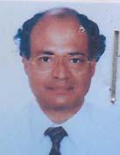 | DR. MUSHFIQUE AHMED CHOWDHURY  F/Name: Late. Shafique Uddin Ahmed Chowdhury  M/Name: Mrs. Jannat Ara Khanom  BM & DC Reg. No: 15059  NID: 2693717211662  Cell: 01711264570  Address: Medical Officer, Upazilla Health Complex, Muktagacha, Mymensingh  Blood Group: A-
381 | Voter No  LM-4100381  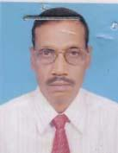 | DR. MD. TAJUL ISLAM  F/Name: Late. Md. Idris Ali  M/Name: Late. Zebunnesa  BM & DC Reg. No: 11610  NID: 6125202110638  Cell: 01911277446  Address: 5/A, Outer Stadium, Kashor, Mymensingh  Blood Group: O+
382 | Voter No  LM-4100382 | DR. CHANDAN CHAKROBORTY  F/Name: Late. Sudir Chakroborty  M/Name: Late. Anima Chakroborty  BM & DC Reg. No: 15467  NID: 6125207157469  Cell: 01715154657  Address: 13, Harikishore Roy Road, Mymensingh  Blood Group: B+
383 | Voter No  LM-4100383 | DR. MIR ANWAR HOSSAIN  F/Name: Mir Mahbub Hossain  M/Name: Anwara Begum  BM & DC Reg. No: 32647  NID: 6125205136109  Cell: 01714312318  Address: 35, College Road (Mir Bari Sarak), Mymensingh  Blood Group: AB_po
384 | Voter No  LM-4100384  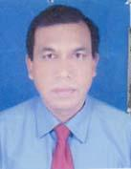 | DR. MD. YOUNUS ALI  F/Name: Late. Hasan Ali  M/Name: Shakorjan  BM & DC Reg. No: 17437  NID: 6122003206026  Cell: 01711315742  Address: Mph in health promotion & health education, Bari Lodge, 27 Sahra Dhopakhala, Mymensingh-2200  Blood Group: O+
385 | Voter No  LM-4100385  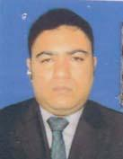 | DR. ARUP ISLAM  F/Name: Md. Anwarul Islam  M/Name: Raushan Ara Chaudhury  BM & DC Reg. No: 41899  NID: 6125201106457  Cell: 01714092280  Address: 338/3, Dholadia (Khagdahor), Raushan Villa, Mymensingh  Blood Group: O+
386 | Voter No  LM-4100386  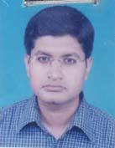 | DR. KAZI MOBASHARUL ISLAM  F/Name: K. M. Shamsul Islam  M/Name: Lutfunnessa Nadira  BM & DC Reg. No: 34286  NID: 6125221273515  Cell: 01715306351  Address: C/O: Selim Mustansir, 183 Rowshad Mansion, Sankipara Shesmoor, Mymensingh  Blood Group: B+
387 | Voter No  LM-4100387  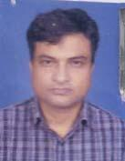 | DR. CHITTA RANJAN DEBNATH  F/Name: Late. Dharma Narayan Debnath  M/Name: Late. Benata Debe  BM & DC Reg. No: 17088  NID: 6125214204790  Cell:  Address: Asst. Prof. of Hepatology, Mymensingh Medical College  Blood Group: B+
388 | Voter No  LM-4100388  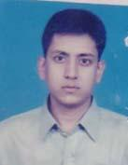 | DR. MUHAMMAD MASUD HASAN  F/Name: A. K. M. Anwarul Islam  M/Name: Nurun Nahar  BM & DC Reg. No: 42216  NID: 6125210175203  Cell: 01712524219  Address: Anesthesiologist, 50, Boundary Road, Mymensingh  Blood Group: B+
389 | Voter No  LM-4100389  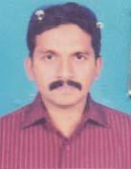 | DR. MD. HAFIZUR RAHMAN  F/Name: A. K. M Saokat Ali  M/Name: Fatema Begum  BM & DC Reg. No: 50004  NID: 6125216218908  Cell: 01711070392  Address: 37/1, Bashmara Road, Mymensingh  Blood Group: B+
390 | Voter No  LM-4100390  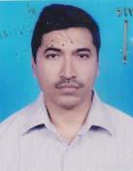 | DR. MD. MASUDUR RAHMAN  F/Name: Late. Habibur Rahman  M/Name: Asia Khatun  BM & DC Reg. No: 18957  NID: 6125209284703  Cell: 01715110954  Address: Sayem Diagno Complex, D.B Road, Sehora, Mymensingh  Blood Group: O+
391 | Voter No  LM-4100391  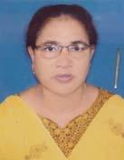 | DR. HAMIDA AKHTER  F/Name: Md. Abdur Rahman  M/Name: Nurjahan Begum  BM & DC Reg. No: 16941  NID: 6125214202858  Cell: 01711805791  Address: Assistant Professor, Dept. of Gynae & Obs. Mymensingh Medical College  Blood Group: O+
392 | Voter No  LM-4100392  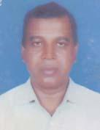 | DR. MANZURUL BARI  F/Name: Abdul Bari  M/Name: Morium Begum  BM & DC Reg. No: 14641  NID: 6125216217117  Cell: 01711048265  Address: 30/2, Shehora, Rumpa Nursing Home, Mymensingh  Blood Group: B+
393 | Voter No  LM-4100393  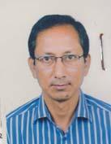 | DR.MD.HABIBUR RAHMAN TAREK  F/Name: Md. Zahir Uddin Ahammad  M/Name: Mrs. Hamida Akter  BM & DC Reg. No: 24848  NID: 19682694811013322  Cell: 01711608586  Address: 265/1,Notun Bazar,Maskanda,Mymensingh  Blood Group: A+
394 | Voter No  LM-4100394  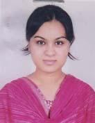 | DR. NAHID RAHMAN  F/Name: Md. Matiur Rahman  M/Name: Nazma Sultana  BM & DC Reg. No: 57313  NID: 6125203123271  Cell: 01722291784  Address: 44/Ka, K.C Roy Road, Mymensingh  Blood Group: O+
395 | Voter No  LM-4100395  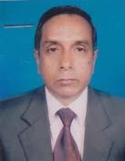 | DR. MD. MATIUR RAHMAN  F/Name: Md. Khoda Newaz  M/Name: Ayesha Begum  BM & DC Reg. No: 10950  NID: 2699039981029  Cell:  Address: Principal, Mymensingh Medical College  Blood Group: B+
396 | Voter No  LM-4100396  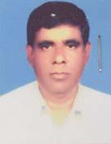 | DR. MISBAH UDDIN AHMED  F/Name: Jahir Uddin Ahmed  M/Name: Rokeya Begum  BM & DC Reg. No: 14792  NID: 6125214208347  Cell: 01712055110  Address: 5/F Medical Staff Quarter, Charpara, Mymensingh  Blood Group: A+
397 | Voter No  LM-4100397  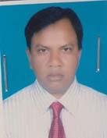 | DR. MD. SYDUR RAHMAN SAWKAT  F/Name: Md. Chan Miah  M/Name: Begum Badrunnesa  BM & DC Reg. No: 26975  NID: 6125215212796  Cell: 01711167916  Address: 252 Charpara, Mymensingh  Blood Group: A+
398 | Voter No  LM-4100398  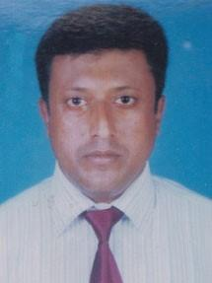 | DR. SHARIF AHMED  F/Name: Md Nazrul Islam  M/Name: Late Mrs Sultana Begum  BM & DC Reg. No: A-50009  NID:  Cell: 01818115994  Address: Sultana Villa, 20/5 Fulbaria Road Azua, Mymensingh  Blood Group:
399 | Voter No  LM-4100399  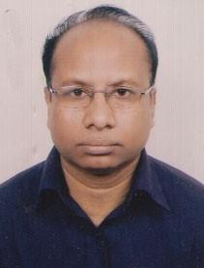 | DR. PARIKSHIT KUMAR PARH  F/Name: Late Debendra Nath Parh  M/Name: Late Sumoti Prava  BM & DC Reg. No: A-19240  NID:  Cell: 01715029505  Address: 86/1 Ck Ghose Road Mymensingh  Blood Group:
400 | Voter No  LM-4100400  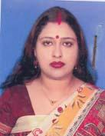 | DR. DEVJANI SANYAL  F/Name: Dr. Lakshmi Kanta Sanyal  M/Name: Anju Sanyal  BM & DC Reg. No: 48011  NID: 6125207156661  Cell: 017111370  Address: Upazilla Health Complex, Dhobaura, Mymensingh  Blood Group:
401 | Voter No  LM-4100401 | dR. aNUPAM BHATTACHARJEE  F/Name: Late. Ashim Kumar Bhattacharjee  M/Name: Jharna Bhattacharjee  BM & DC Reg. No: 37966  NID: 615207156618  Cell: 01712738647  Address: Upazila Health Complex, Dobaura, Mymensingh  Blood Group: O+
402 | Voter No  LM-4100402  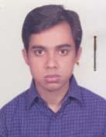 | DR. ANIRUDHAW BHATTACHARJEE  F/Name: Late. Ashim Kumar Bhattacharjee  M/Name: Jharna Bhattacharjee  BM & DC Reg. No: 49583  NID: 8524904043212  Cell: 01717786450  Address: 14, Horikishore Roy Road, Mymensingh  Blood Group: O+
403 | Voter No  LM-4100403  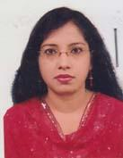 | DR. SAIMA ANWAR  F/Name: Late. Anwarul Haque  M/Name: Late. Dr. Shamim Aktar  BM & DC Reg. No: 41143  NID: 6125218475806  Cell: 01712620447  Address: 48/B, Dawlat Munshi Bi-Lane, Krisnopur, Mymensingh  Blood Group: O+
404 | Voter No  LM-4100404 | DR. BILIOM ANISIM SANGMA  F/Name: Shishir Kumar Sangma  M/Name: Probha Sangma  BM & DC Reg. No: 42678  NID: 6125219259185  Cell: 01711167946  Address: 6/2 Baghmara Road, Vatikhashor, Mymensingh-2200  Blood Group: B+
405 | Voter No  LM-4100405 | DR. KRIPADHAN CHAKROBORTY  F/Name: Late. Roy Mohon Chakroborty  M/Name: Ashalata Chakroborty  BM & DC Reg. No: 30624  NID:  Cell: 01732252706  Address: 22/B, C.K Goash Road, Mymensingh  Blood Group: O+
406 | Voter No  LM-4100406  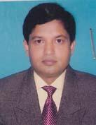 | DR. GOURANGA SAHA  F/Name: Hemendra Lal Saha  M/Name: Mrinalini Saha  BM & DC Reg. No: 17297  NID: 6125216217231  Cell: 01711134338  Address: 29 A, R.K Mission Road, Mymensingh  Blood Group: A+
407 | Voter No  LM-4100407  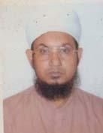 | DR. MD. YAKUB ALI  F/Name: Late. Md. Intiaz Ali Sarder  M/Name: Late. Sobezan Bebe  BM & DC Reg. No: 16080  NID: 2694813884865  Cell: 01720545270  Address: MO (Against Junior Consultant Ortho-Surgery), Trauma Centre, Bhaluka, Mymensingh  Blood Group: B+
408 | Voter No  LM-4100408  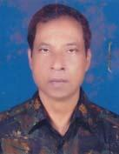 | DR. A. K. M. ABDUL AWAL KHAN  F/Name: Late. Jalal Uddin Khan  M/Name: Late. Hasna Aktar Khanam  BM & DC Reg. No: 16497  NID:  Cell: 01711044583  Address: Niribili, Akua (S), Khalpar, Mymensingh  Blood Group: O+
409 | Voter No  LM-4100409  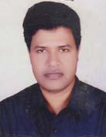 | DR. NETAY KUMER SHARMA  F/Name: Noren Chandra Sharma  M/Name: Pushpo Rani Sharma  BM & DC Reg. No: 45678  NID: 6921503593757  Cell: 01711962023  Address: Dewan Manjil, 58/5 Medical College Gate, Bilane, Nayapara, Charpara, Mymensingh  Blood Group: B+
410 | Voter No  LM-4100410 | DR. UZZAL KUMAR NAG  F/Name: Rabindra Nath Nag  M/Name: Sabita Rani Nag  BM & DC Reg. No: 27433  NID: 24209612145  Cell: 01711956735  Address: Room: 07, Examiners Lounge, Mymensngh Medical College, Mymensingh  Blood Group: B+
411 | Voter No  LM-4100411  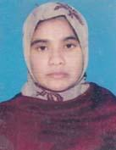 | DR. HASBI ARA MOSTOFA  F/Name: Dr. Mohammad Golam Mostofa  M/Name: Hasna Ara Begum  BM & DC Reg. No: 50948  NID: 6125210176916  Cell: 01717921581  Address: House: 09 (2nd Floor), Rd No: 11, Nikunjo-2, Dhaka  Blood Group: O+
412 | Voter No  LM-4100412  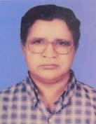 | DR. MD. GOLAM MUSTAFA  F/Name: Md. Jamshed Ali  M/Name: Mst. Rabeya Khatun  BM & DC Reg. No: 10283  NID:  Cell: 01715154636  Address: Vill: Darirampur, Ward: 08, Trishal Pourashava, Dist: Mymensingh  Blood Group: B+
413 | Voter No  LM-4100413  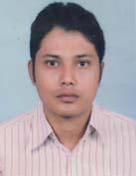 | DR. PALASH CHANDRA SAHA ROY  F/Name: Parimal Chandra Saha Roy  M/Name: Kalpona Saha  BM & DC Reg. No: 51514  NID: 6127205169071  Cell: 01712005540  Address: 146, Dhan Mahal Road, Nandail Bazar, PO & PS: Nandail, Dist: Mymensingh  Blood Group: O+
414 | Voter No  LM-4100414  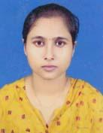 | DR. JOYOSREE PAUL  F/Name: Dilip Kumar Paul  M/Name: Nilima Rani Paul  BM & DC Reg. No: 36424  NID: 8928804119458  Cell: 01712021916  Address: M.O (Forensic Medicine), Mymensingh Medical College, Mymensingh  Blood Group: B+
415 | Voter No  LM-4100415  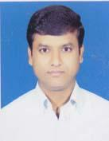 | DR. MALAY KUMAR SAHA  F/Name: Amarendra Mohan Saha  M/Name: Mina Rani Saha  BM & DC Reg. No: 24785  NID: 8928804119439  Cell: 01715637827  Address: R.S (Casualty), Mymensingh Medical College Hospital, Mymensingh  Blood Group: A+
416 | Voter No  LM-4100416  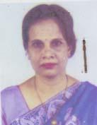 | DR. TAYEEBA TANJIN MIRZA  F/Name: Late. Mirza Abu Hanif  M/Name: Mrs. Nurjahan Hanif  BM & DC Reg. No: 019388  NID: 6125220263968  Cell: 01711282838  Address: Associate Prof. (Gynae & Obs), MMCH  Blood Group: B+
417 | Voter No  LM-4100417  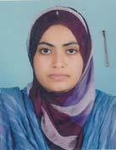 | DR. SNIGDHA RAHMAN TITIR  F/Name: Md. Matiur Rahman Bhuiyan  M/Name: Jahura Begum  BM & DC Reg. No: 51863  NID: 6125214204701  Cell: 01674873228  Address: 1/A, Medical Quarter, Mymensingh Medical College, Mymensingh  Blood Group: A+
418 | Voter No  LM-4100418  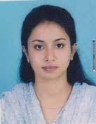 | DR. NUSRAT SULTANA NINIYA  F/Name: Prof. Dr. M. A. Gafur Mia  M/Name: Mahbub Ara Rozy  BM & DC Reg. No: 56131  NID: 8524904042259  Cell: 01717255331  Address: 306/27 Amirabad Residential Area, Amirabad, Mashkanda, Mymensingh  Blood Group: A+
419 | Voter No  LM-4100419  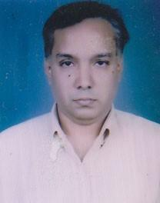 | DR. MAHBUBUR RAHMAN  F/Name: Md Boshir Uddin Bhuiyan  M/Name: Mrs Rozia Akter  BM & DC Reg. No: A-20327  NID:  Cell:  Address: 114/3 Ram Krishey Mission Road Mymensingh  Blood Group:
420 | Voter No  LM-4100420  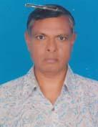 | DR. MD. NURUL HOQUE  F/Name: Late. Mvi Shariat Ullah  M/Name: Late. Rahima Khatun  BM & DC Reg. No: 13723  NID: 6122205137662  Cell: 01711025737  Address: Emergency Medical Officer, Upazilla Health Complex, Gaffargaon, Mymensingh  Blood Group: O+
421 | Voter No  LM-4100421  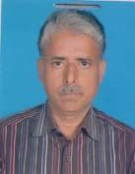 | DR. MD. TUFAEL HOSSAIN  F/Name: Late. Dr. Mohammad Hossain  M/Name: Late. Mst. Shafia Khatun  BM & DC Reg. No: 12861  NID: 6119415756613  Cell: 01915454179  Address: Assistant Professor, Community Medicine, CBMCB, Mymensingh  Blood Group: B+
422 | Voter No  LM-4100422  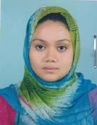 | DR. ISRAT SULATANA ZINIYA  F/Name: Prof. M.A Gafur  M/Name: Mahbub Ara  BM & DC Reg. No: 55117  NID: 2716469409799  Cell: 01737645536  Address: 306/27, Amirabad, Mashkanda, Mymensingh  Blood Group: A+
423 | Voter No  LM-4100423 | DR. MD. SHAWKAT ALI  F/Name: Late. Md. Rashid Ali  M/Name: Atabunnessa  BM & DC Reg. No: 13277  NID: 2692620519862  Cell: 01711400213  Address: Department of Gastroenterology, Mymensingh Medical College Hospital, Mymensingh  Blood Group: A+
424 | Voter No  LM-4100424 | DR. MD. MATIUR RAHMAN  F/Name: Md. Shakwat Ali Mir  M/Name: Mrs. Fozila Khatun  BM & DC Reg. No: 28973  NID: 6125217236339  Cell: 01711612095  Address: 3/B, Baghmara Medical Gate, Mymensingh  Blood Group: A+
425 | Voter No  LM-4100425  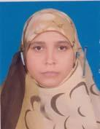 | DR. NURE AKTER SYEADA ISLAM  F/Name: Md. Nurul Islam  M/Name: Mrs. Sulema Khatun  BM & DC Reg. No: 52085  NID: 6125217228305  Cell: 01711612095  Address: 3/B, Baghmara Medical Gate, Mymensingh  Blood Group: A+
426 | Voter No  LM-4100426  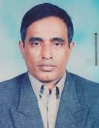 | DR. MD. MOMINUR RAHMAN  F/Name: Dr. Md. Lukman Ali  M/Name: Begum Muslema Khatun  BM & DC Reg. No: 20188  NID:  Cell: 01711631578  Address: 46/D, Padri Mission Road, Mymensingh  Blood Group: O+
427 | Voter No  LM-4100427  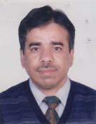 | DR. A. S. M. IQBAL HOSSAIN CHOWDHURY  F/Name: Late. Md. Delwar Hossain Chowdhury  M/Name: Late. Jahanara Begum  BM & DC Reg. No: 18315  NID: 6125218237134  Cell: 01711683779  Address: Junior Consultant (Ortho), UHC, Trisal, Mymensingh  Blood Group: B+
428 | Voter No  LM-4100428  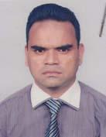 | DR. MD. MOJIBUR RAHMAN  F/Name: Md. Abdul Mannan  M/Name: Mrs. Marzina Begum  BM & DC Reg. No: 25109  NID: 6125218237159  Cell: 01711976717  Address: 42/E, Baghmara Road (2nd Floor), Mymensingh-2200  Blood Group: O+
429 | Voter No  LM-4100429  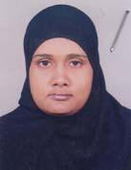 | DR. NASRIN JAHAN KHAN  F/Name: Md. Sirajul Haque Khan  M/Name: Mrs. Shamsunnahar  BM & DC Reg. No: 33065  NID: 6125218237125  Cell: 01712676654  Address: 42/E, Baghmara Road, Mymensingh-2200  Blood Group: O+
430 | Voter No  LM-4100430  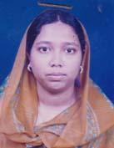 | DR. RUBAIYA ISLAM NAUMI  F/Name: Md. Nazrul Islam  M/Name: Rokeya Jesmeen  BM & DC Reg. No: 53021  NID: 6125217234778  Cell: 01710927806  Address: 32, Brahmapolli, Mymensingh  Blood Group: B+
431 | Voter No  LM-4100431  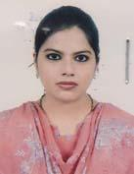 | DR. NAUREEN SAYEED MUMU  F/Name: Prof. Dr. Saiyeedur Rahman  M/Name: Asma Rahman  BM & DC Reg. No: 56550  NID: 6125210176028  Cell: 01716915496  Address: Remas, House: 22, Boundary Road, Mymensingh  Blood Group: O+
432 | Voter No  LM-4100432  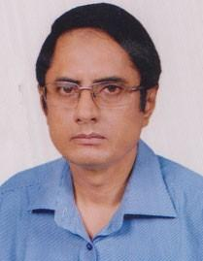 | DR. MD HABIBULLAH KHAN  F/Name: Dr Md Habibur Rahman Khan  M/Name: Ziinab Habib  BM & DC Reg. No: 8631  NID:  Cell: 01611506121  Address: 42/1 Daulot Nurshi Lane Kristopur Mymensingh  Blood Group:
433 | Voter No  LM-4100433  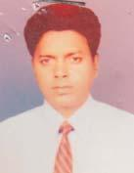 | DR. A. S. M. LOKMAN HOSSAIN CHOWDHURY  F/Name: Late. Md. Nasir Uddin Chowdhury  M/Name: Mrs. Saleha Chowdhury  BM & DC Reg. No: 19759  NID: 9316623911862  Cell: 01819154949  Address: Dept. of Paediatric Surgery, Mymensingh Medical College  Blood Group: O+
434 | Voter No  LM-4100434  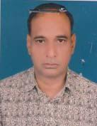 | DR. MD. SHAFIQUZZAMAN  F/Name: Md. Abdul Wahhab  M/Name: Mrs. Rawshan Ara Begum  BM & DC Reg. No: 22921  NID: 6125214204640  Cell: 01716656658  Address: 114/1, Heart Foundation By Lane, Charpara, Mymensingh  Blood Group: A+
435 | Voter No  LM-4100435  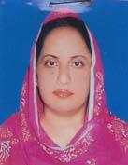 | DR. MST. KHURSHIDA JAHAN  F/Name: Md. Momtaz Ali Shah Fakir  M/Name: Mrs. Firoza Begum  BM & DC Reg. No: 27666  NID: 6125214204641  Cell: 01711201027  Address: 114/1, Heart Foundation By Lane, Charpara, Mymensingh  Blood Group: A+
436 | Voter No  LM-4100436  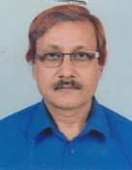 | DR. MD. ATIQUR RAHMAN  F/Name: Late. Shamsur Rahman  M/Name: Amena Begum  BM & DC Reg. No: 8648  NID: 6125206146278  Cell: 01552403303  Address: 309/5 Sugandha Residential Area, Mookanda, Mymensingh  Blood Group: A+
437 | Voter No  LM-4100437  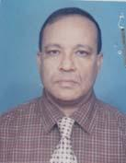 | DR. MAJOR (RETD) MD BADRUZZAMAN  F/Name: Late. Khursheduzzaman  M/Name: Late. Husannahar  BM & DC Reg. No: 10324  NID: 6155298366679  Cell: 01711124609  Address: Aboshar, 290/Kha/6, Mashkanda, Mymensingh, Near Momenshahi, Fillisp Station  Blood Group: O+
438 | Voter No  LM-4100438  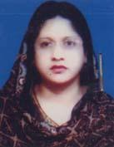 | DR. AKTER ZAHAN  F/Name: Md. Mofazzal Hossain  M/Name: Begum Bazlun Nahar  BM & DC Reg. No: 33961  NID: 6115223354480  Cell: 01711489976  Address: 34/19/1 Nayapara, Charpara, Mymensingh  Blood Group: O+
439 | Voter No  LM-4100439  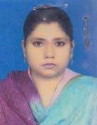 | DR. TASLIMA KHANOM  F/Name: Late. Abdus Salam Khan  M/Name: Mrs. Ambia Khanom  BM & DC Reg. No: 39236  NID: 6125210177054  Cell: 01720033507  Address: 65, Naha Road, Nahar Bari, Mymensingh-2200  Blood Group: O+
440 | Voter No  LM-4100440  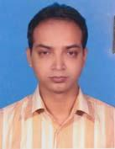 | DR. BIJOY KUMER PAUL  F/Name: Dulal Chandra Paul  M/Name: Mira Rani Paul  BM & DC Reg. No: 32984  NID:  Cell: 01712109240  Address: 8/2 Girish Chakroborty Road, Mymensingh  Blood Group: A+
441 | Voter No  LM-4100441 | DR. MD. ABDUL KHALEQUE  F/Name: Late. Yeakub Ali  M/Name: Mrs. Zahera Khatun  BM & DC Reg. No: 21747  NID: 6125214203786  Cell: 01733719580  Address: Dept. of Paediatrics, Mymensingh Medical College  Blood Group: A+
442 | Voter No  LM-4100442  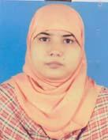 | DR. RAWSHAN ARA  F/Name: Md. Abdur Rahman  M/Name: Zohora Begum  BM & DC Reg. No: 48493  NID: 2694267806867  Cell: 01731347240  Address: 93, R.K Mission Road, Mymensingh  Blood Group: AB_po
443 | Voter No  LM-4100443 | DR. RATAN KUMAR CHAKRABORTY  F/Name: Satish Chandra Chakraborty  M/Name: Maya Rani Chakraborty  BM & DC Reg. No: 24664  NID: 6125214166033  Cell: 01711624647  Address: Asst. Prof. & SMO, Centre For Nuclear Medicine & Ultrasound, Mymensingh  Blood Group: AB_po
444 | Voter No  LM-4100444  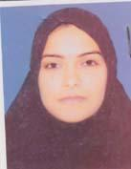 | DR. LAILA KAMRUZZAMAN PANNA  F/Name: Abdul Hamid Mondol  M/Name: Helena Hamid  BM & DC Reg. No: 42241  NID: 3313023314029  Cell: 01711070640  Address: 63/4, Puruhitpara, Mymensingh  Blood Group: B+
445 | Voter No  LM-4100445 | DR. MOHAMMAD AFZALUR RAHMAN  F/Name: Abdullahel Kafi  M/Name: Nurun Nahar Begum  BM & DC Reg. No: 29987  NID: 6125216220165  Cell: 01712080496  Address: 63/4, Purohit Para, Mymensingh-2200  Blood Group: O+
446 | Voter No  LM-4100446  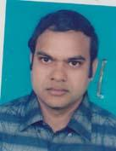 | DR. ELIUS AHMED  F/Name: Dr. A. B. Siddique  M/Name: Sufia Khatun  BM & DC Reg. No: 38003  NID: 6119428742318  Cell: 01720578476  Address: 107/4, D.B Road, Sehra, Mymensingh  Blood Group: O+
447 | Voter No  LM-4100447  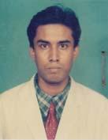 | DR. KIRITI RANJAN DAS  F/Name: Arun Kumar Das  M/Name: Shakti Rani Das  BM & DC Reg. No: 43472  NID: 6125207155434  Cell: 01712106753  Address: 14 T.N Roy Road, Amlapara, Mymensingh  Blood Group: A+
448 | Voter No  LM-4100448  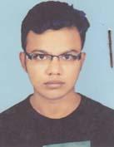 | DR. KHANDAKAR RASHED AHMED  F/Name: Khandakar Raisuddin Ahmed  M/Name: Parvin Aktar  BM & DC Reg. No: 51927  NID: 6125217276920  Cell: 01912458727  Address: Room No: 403, Internee Hostel, MMCH, Mymensingh.  Blood Group: A+
449 | Voter No  LM-4100449 | DR. KAMRUL ASHRAF  F/Name: Late. Ashraf Hossain  M/Name: Ripa Hossain  BM & DC Reg. No: 51870  NID:  Cell: 01712142476  Address: Internee Hostel, MMCH  Blood Group: AB_po
450 | Voter No  LM-4100450  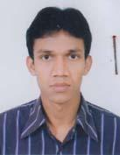 | DR. MD. MORSHED ALAM  F/Name: Md. Abdul Jalil Sheikh  M/Name: Rejia Khatun  BM & DC Reg. No: 51867  NID: 6125217227619  Cell: 01723808147  Address: Shahid Dr. Milon Hostel, Room: 414, MMCH, Mymensingh  Blood Group: A+
451 | Voter No  LM-4100451  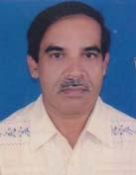 | DR. MD. ANWAR HOSSAIN  F/Name: Md. Arfan Ali Sarker  M/Name: Shahitonnesa  BM & DC Reg. No: 14781  NID: 6125214202855  Cell: 01716344689  Address: Assistant Professor, Department of Neonatology, Mymensingh Medical College  Blood Group: O+
452 | Voter No  LM-4100452  No Image | DR. MD. AMJAD HOSSAIN KHAN  F/Name: Md. Feroz Miah  M/Name:  BM & DC Reg. No:  NID:  Cell:  Address: Jr. Consultant, Pediatrics Department, MMCH, Mymensingh.  Blood Group:
453 | Voter No  LM-4100452  No Image | DR. MD. AMJAD HOSSAIN KHAN  F/Name: Md. Feroz Miah  M/Name:  BM & DC Reg. No:  NID:  Cell:  Address: T.F. BMA Jamalpur Br. LM-2300004  Nex Gazipur LM-2000269 .  Blood Group:
454 | Voter No  LM-4100454  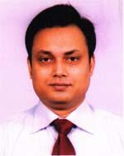 | DR. MANIK MAZUMDER  F/Name: Biswanath Mazumder  M/Name: Mina Mazumder  BM & DC Reg. No: 32982  NID: 6125215212399  Cell: 01711619086  Address: 34/4, Mina Kunja , New Residential Area, Nayapara, Charpara, Mymensingh-2200  Blood Group: O+
455 | Voter No  LM-4100455  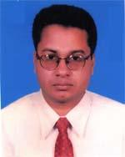 | DR. MOHAMMAD KAMRUZZAMAN KHAN  F/Name: Mohammad Dilawar Hossain Khan  M/Name: Mrs. Saleha Khanam  BM & DC Reg. No: 30026  NID: 19749196211000018  Cell: 01711365126  Address: Akanda Bari, Level 3, 49, Coronation Road, Kashor, Police Line, Mymensingh-2200  Blood Group: O+
456 | Voter No  LM-4100456  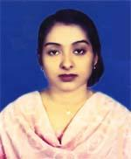 | DR. JANNATUL FERDOUS  F/Name: Mohammad Abdul Gafur Akanda  M/Name: Mrs. Razia Akanda  BM & DC Reg. No: 35134  NID: 1975919621100009  Cell: 01716172229  Address: Akanda Bari, Level 3, 49, Coronation Road, Kashor, Police Line, Mymensingh-2200  Blood Group: O+
457 | Voter No  LM-4100457  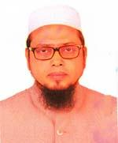 | DR. MD. NAZRUL ISLAM  F/Name: Late Mohi Uddin Ahmed  M/Name: Mrs. Rawshan Akter  BM & DC Reg. No: 27423  NID: 6125216217887  Cell: 01711247222  Address: 5/3, Sehra, Dhaka Road, Mymensingh  Blood Group: O+
458 | Voter No  LM-4100458  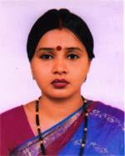 | DR. ALPANA RANI ROY  F/Name: Late Sattya Narayan Roy  M/Name: Aroti Rani Roy  BM & DC Reg. No: 50863  NID: 8198510364132  Cell: 01717143414  Address: 34/4, Mina Kunja, New Residential Area, Nayapara, Charpara, Mymensingh-2200  Blood Group: B+
459 | Voter No  LM-4100459  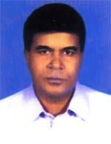 | MD. SHAHIDUL BASHER  F/Name: Md. Abdur Rahman Talukder  M/Name: Mst. Hosney Ara Begum  BM & DC Reg. No: 12664  NID: 6125210176713  Cell: 01727428445  Address: 19/2, Jamir Munshee Bylane, Peonpara, Notun Bazar, Mymensingh  Blood Group: B+
460 | Voter No  LM-4100460  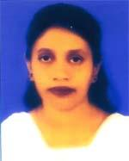 | DR. SHIKHA KABIR  F/Name: Md. Mobaraque Hossain Bhuiyan  M/Name: Ommehany  BM & DC Reg. No: 29294  NID: 6125210176712  Cell: 01711984450  Address: 19/2, Jamir Munshi Bilane, Natun Bazar, Mymensigh  Blood Group: B-
461 | Voter No  LM-4100461  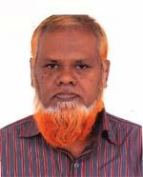 | DR. MD. HASAN JAMAL FAKIR  F/Name: Late Md. Miras Uddin Fakir  M/Name: Late Salimunnessa Begum  BM & DC Reg. No: 12591  NID: 3022910105818  Cell: 01716196977  Address: Assoc. Prof. Health of Dept. of Paediatrics MMC  Blood Group: B+
462 | Voter No  LM-4100462 | DR. SAJUTI SARKAR  F/Name: Chandan Kumar Sarkar  M/Name: Archana Sarkar  BM & DC Reg. No: 50158  NID: 9326602056892  Cell: 01711381325  Address: 8/2, Girish Chakraborty Road, Mymensingh Sadar, Mymensingh  Blood Group: B+
463 | Voter No  LM-4100463 | DR. S.M.SHAHIDUZZAMAN SUMAN  F/Name: Muhammad Abdul Halim Sarker  M/Name: Nurun Nahar  BM & DC Reg. No: A54199  NID: 6125217276865  Cell: 01719597497  Address: Mymensingh Medical College Mymensingh  Blood Group: A+
464 | Voter No  LM-4100464  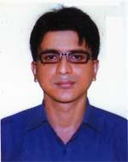 | DR. MUHAMMAD AZIZUR RAHMAN BHUIYAN  F/Name: Muhammad Ataur Rahman Bhuiyan  M/Name: Takjima Akter  BM & DC Reg. No: 65042  NID: 8198510364532  Cell: 01717999579  Address: 93, R.k. Mission Road, Mymensingh  Blood Group: A+
465 | Voter No  LM-4100465 | DR. MOHAMMAD TARIQUL ALAM  F/Name: Mohammad Taher Uddin  M/Name: Late Rezia Khatun  BM & DC Reg. No: 41464  NID: 2694262664093  Cell: 01758032247  Address: 8/Gha, Jamir Munshi Lane, Peonpara, Mymensingh  Blood Group: A+
466 | Voter No  LM-4100466  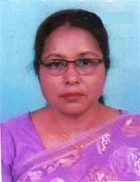 | DR. FIROZA BEGUM  F/Name: Md. Osman Ali  M/Name: Maleka Begum  BM & DC Reg. No: 16681  NID: 6125216226556  Cell: 01711969686  Address: 5/F Medical Staff Quarter, Charpara, Mymensingh  Blood Group: B+
467 | Voter No  LM-4100467  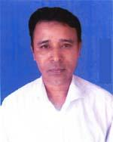 | DR. MOHAMMAD JAHANGIR ALAM KHAN  F/Name: Abdul Hamid Khan  M/Name: Raneya Khan  BM & DC Reg. No: 32350  NID: 9196203131441  Cell: 01711440471  Address: Asst. Prof. ENT Department, Mymensingh Medical College  Blood Group: B+
468 | Voter No  LM-4100468  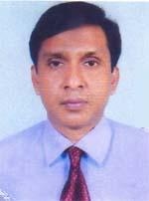 | DR. UTTAM KUMAR DAS  F/Name: Gouranga Chandra Das  M/Name: Karuna Rani Das  BM & DC Reg. No: 31579  NID: 6125216289693  Cell: 01712518082  Address: 8/D, Doctors Quarter, Mymensingh, Medical College Hosspital  Blood Group: O+
469 | Voter No  LM-4100469  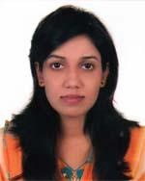 | DR. SUBARNA RANI DEY  F/Name: Subal Chandra Dey  M/Name: Mira Rani Dey  BM & DC Reg. No: 75559  NID: 19916125207000021  Cell: 01738035006  Address: 2/3, Mrittunjoy School Road, Mymensingh  Blood Group: B+
470 | Voter No  LM-4100470  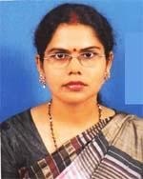 | DR. SANTANA RANI SARKAR  F/Name: Late Nimai Krishna Sarkar  M/Name: Sobita Sarkar  BM & DC Reg. No: 38851  NID: 2616294391706  Cell: 01716075694  Address: 2/A, Medini Hye Tower, 61, Saroda Ghose Road, Mymensingh  Blood Group: B+
471 | Voter No  LM-4100471  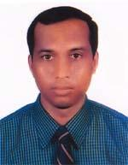 | DR. NITAI CHANDRA RAY  F/Name: Jagodish Chandra Ray  M/Name: Golapi Rani Ray  BM & DC Reg. No: 29985  NID: 2616294391705  Cell: 01715108760  Address: 2/A, Medini Hye Tower, 61, Saroda Ghose Road, Mymensingh  Blood Group: B+
472 | Voter No  LM-4100472  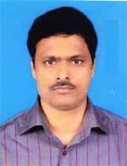 | DR. MANABENDRA BHATTACHARJEE  F/Name: Satyendra Kumar Bhattacharjee  M/Name: Tripti Bhattacharjee  BM & DC Reg. No: 27272  NID: 19714824908342005  Cell: 01711383744  Address: Dept. of Nurology , Mymensingh Medical College  Blood Group: A+
473 | Voter No  LM-4100473 | DR. RUMPA BISWAS  F/Name: Satyendra Narayan Biswas  M/Name: Shipra Lahiri  BM & DC Reg. No: 49367  NID: 8198510362953  Cell: 01712260048  Address: Imo, Dept. of Radilogs, Mymensingh Medical College Hospital  Blood Group: A+
474 | Voter No  LM-4100474 | DR. SHAKER AHMED  F/Name: Abdul Hamid  M/Name: Shokhina Khatun  BM & DC Reg. No: 33037  NID: 6125214204477  Cell: 01711906650  Address: Assistant Professor (ENT) Dept. of ENT , Mymensingh Medical College  Blood Group: AB+
475 | Voter No  LM-4100475  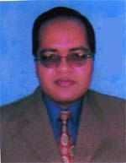 | DR. FARID AHAMED  F/Name: Alhaj M. A. Gafur Sarker  M/Name: Begum Sufia Khatoon  BM & DC Reg. No: 25371  NID: 9325705854029  Cell: 01711649199  Address: Asst. Prof. Dept. of Microbiology, MMC. Mymensingh.  Blood Group: B+
476 | Voter No  LM-4100476 | DR. SHAMSUN NAHAR  F/Name: Alhaj Nur Mohammed  M/Name: Mrs. Anowara Khatoon  BM & DC Reg. No: 31117  NID: 3923605137107  Cell: 01718234874  Address: Junior Consultant (Gynee & Obs) MMCH, Mymensingh.  Blood Group: B+
477 | Voter No  LM-4100477  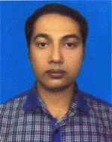 | DR. MUHAMMED HARUN AL MAKSUD  F/Name: Muhammed Nazrul Islam  M/Name: Jusna Begum  BM & DC Reg. No: 45593  NID: 6112053418525  Cell: 01712194445  Address: Upazilla Health Complex, Fulbaria, Mymensingh  Blood Group: B+
478 | Voter No  LM-4100478  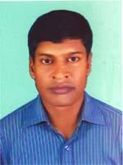 | DR. BIDHAN CHANDRA DEBNATH  F/Name: Jatindra Chandra Debnath  M/Name: Momota Debi  BM & DC Reg. No: 33710  NID: 6122003213721  Cell: 01711981060  Address: Fulbaria Puraton Garuhata, Fulbaria Bazar, Upazilla-Fulbaria, Dist-Mymensingh  Blood Group: B+
479 | Voter No  LM-4100479 | DR. MOHAMMAD HASANUL HOSSAIN  F/Name: Abu Sayed Mohammad Nowshad Hossain  M/Name: Mrs. Hasina Begum  BM & DC Reg. No: 47436  NID: 6129407715097  Cell: 01555223344  Address: Medical officer, UHC, Trishal, Mymensingh  Blood Group: A+
480 | Voter No  LM-4100480  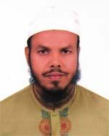 | DR. MD. RAFIQUL ISLAM  F/Name: Late Alim Uddin  M/Name: Late Mullukjan  BM & DC Reg. No: 23813  NID: 2691650169036  Cell: 01712583814  Address: Junior Consultant (ENT), UHC, Trisal, Mymensingh  Blood Group: O+
481 | Voter No  LM-4100481  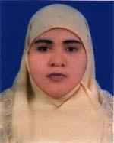 | DR. SABENA EASMIN  F/Name: Abul Kalam  M/Name: Mrs. Lutfunnahar  BM & DC Reg. No: 30757  NID: 2691650169035  Cell: 01712550483  Address: Jn. Consultant (Gynee), UHC, Trishal, Mymensingh  Blood Group: AB+
482 | Voter No  LM-4100482  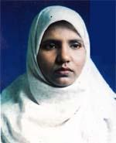 | DR. MARZIA AKANDA  F/Name: Abdul Hai Akanda  M/Name: Anwara Begum  BM & DC Reg. No: 38975  NID: 6125204128972  Cell: 01711186697  Address: 186, Ghail Kandi, Mymensingh  Blood Group: A+
483 | Voter No  LM-4100483  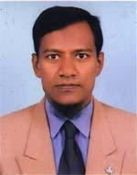 | MD. RABEUL KARIM  F/Name: Md. Ashraf Hossain  M/Name: Rabeya Khatun  BM & DC Reg. No: 26382  NID: 6125204128822  Cell: 01720538921  Address: 186, Gohail Kandi, Mymensingh  Blood Group: O+
484 | Voter No  LM-4100484  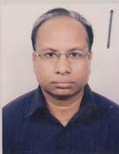 | DR. PARIKSHIT KUMAR PARH  F/Name: Late Debendra Nath Parh  M/Name: Late Sumoti Prava  BM & DC Reg. No: 19240  NID: 8928802110084  Cell: 01715029505  Address: 86/1, C.K. Ghose Road, Mymensingh  Blood Group: AB+
485 | Voter No  LM-4100485  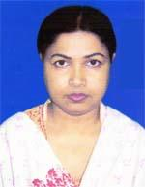 | DR. MOSAMMAT FERDEWSI BEGUM  F/Name: Golam Baset  M/Name: Mrs. Kohinur Begum  BM & DC Reg. No: 39613  NID: 19762924704131716  Cell: 01718876734  Address: N/H, Medical staff Quarter , Charpara, Mymensingh  Blood Group: A-
486 | Voter No  LM-4100486  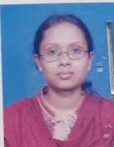 | DR. TAHMINA SHARMIN  F/Name: Gulam Mowla  M/Name: Fatema Akter Khatun  BM & DC Reg. No: 36886  NID: 6125214204119  Cell: 01712212081  Address: 8, Charpara, Mymensingh  Blood Group: O-
487 | Voter No  LM-4100487  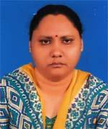 | DR. SABITA DHAR  F/Name: Sunil Chandra Dhar  M/Name: Arati Rani Dhar  BM & DC Reg. No: 28149  NID: 6125208160176  Cell: 01712077447  Address: 16 No. Bara Bazar, Mymensingh  Blood Group: B+
488 | Voter No  LM-4100488 | DR. MOSTAFA MAHMUD RUBEL  F/Name: Md. Sultan Uddin  M/Name: Shaheen Akhter Rubi  BM & DC Reg. No: 55306  NID:  Cell: 01715089669  Address: 205/7, Nayapara, Charpara, Mymensingh  Blood Group: A+
489 | Voter No  LM-4100489  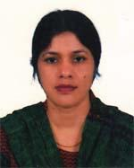 | DR. FERDOUSI BEGUM  F/Name: Md. Forayeb Uddin  M/Name: Mrs. Suraya Begum  BM & DC Reg. No: 33020  NID: 6125205135729  Cell: 01712192071  Address: Asst. Prof. Oblr CBMC Mymensingh  Blood Group: B+
490 | Voter No  LM-4100490  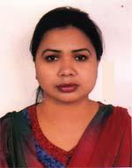 | DR. NAZMA PARVIN ANSARI  F/Name: Md. Ansarul Haque Tarafder  M/Name: Mrs. Rezia Ansar  BM & DC Reg. No: 32103  NID: 6125216218518  Cell: 01727428441  Address: Amt. Prof. of Pathology, Community Based Medical College  Blood Group: B+
491 | Voter No  LM-4100491  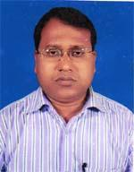 | DR. SULTAN AHMED  F/Name: Late Sadar Uddin  M/Name: Mrs. Hajara Khatun  BM & DC Reg. No: 31176  NID: 6115254598819  Cell: 01717316654  Address: 26 No. South Boundary Road, Sadar, Mymensingh  Blood Group: A+
492 | Voter No  LM-4100492  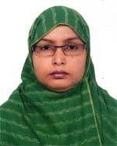 | DR. AMBIA BEGUM  F/Name: Mohammed Ali  M/Name: Anwara Begum  BM & DC Reg. No: 35684  NID: 6125214204865  Cell: 01716763643  Address: Assistant Prof. of Pathology , Department of Pathology, Community Board Medical College (CBMC), Mymensingh.  Blood Group: A+
493 | Voter No  LM-4100493  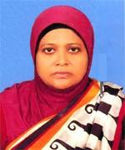 | DR. SHAMIN ARA BEGUM  F/Name: Late Md. Abdul Khaleque  M/Name: Sabera Begum  BM & DC Reg. No: 25284  NID: 19686125210178923  Cell: 01729431833  Address: 56/A, Sarada Gosh Road, (Ncar Natco Bazar Rail Gate), Mymensingh  Blood Group: O+
494 | Voter No  LM-4100494 | DR. ARUP RATAN PAUL  F/Name: Ashit Baran Paul  M/Name: Milon Rani Paul  BM & DC Reg. No: 33810  NID: 6125212193421  Cell: 01716170646  Address: 11/2, T. N. Roy Road, Amlapara, Mymensingh  Blood Group: B+
495 | Voter No  LM-4100495  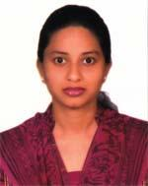 | DR. MANISHA PAUL TUMPA  F/Name: Gouranga Chandra Paul  M/Name: Chadana Paul  BM & DC Reg. No: 66279  NID: 4819294800132  Cell: 01717940861  Address: 11/2, T.N. Roy road, Amlapara, Mymensingh  Blood Group: B+
496 | Voter No  LM-4100496  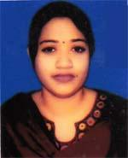 | DR. RUBIAT NAZNIN  F/Name: Mohammad Aminul Islam  M/Name: Tahera Naznin  BM & DC Reg. No: 42382  NID: 6125207665619  Cell: 01718355113  Address: 269/1, Maskanda Road, Mymensingh  Blood Group: O+
497 | Voter No  LM-4100497  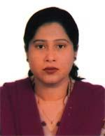 | DR. MAKSUDA BEGUM  F/Name: Md. Hanif Uddin Talukder  M/Name: Mst. Jahanara Begum  BM & DC Reg. No: 37273  NID: 6121306608319  Cell: 01711940984  Address: 50, Porohit Para, Mymensingh  Blood Group: A+
498 | Voter No  LM-4100498  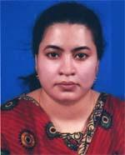 | DR. MST. HABIBA SULTANA  F/Name: Md. Habibur Rahman Mondol  M/Name: Kaniz Shamima Akhter  BM & DC Reg. No: 52236  NID: 73185402022737  Cell: 01717338229  Address: 50, Boundary Road, Mymensingh  Blood Group: O+
499 | Voter No  LM-4100499  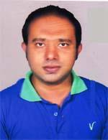 | A.B. M. ILIAS PARVES  F/Name: A.b.m. Osman Ghani  M/Name: Azufa Khatun  BM & DC Reg. No: 63543  NID: 6125205138274  Cell: 01711059230  Address: 76, College Road, Mymensingh  Blood Group: A+
500 | Voter No  LM-4100500  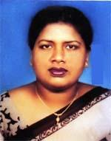 | DR. NAFISA SULTANA SATHI  F/Name: Md. Abul Fazal Talukder  M/Name: Maksuda Begum  BM & DC Reg. No: 37425  NID: 6125206147076  Cell: 01711453028  Address: 48, Aqra Madrasha Quater , Litchu Bagan, Mymensingh  Blood Group: A+
501 | Voter No  LM-4100501 | DR. SK. SADIQUE BIN HABIB  F/Name: Md. Habibur Rahman  M/Name: Kh. Fatema Zahura  BM & DC Reg. No: 65702  NID: 61252002116858  Cell: 01712733303  Address: 119/B, Zail Road, Mymensingh  Blood Group: B+
502 | Voter No  LM-4100502  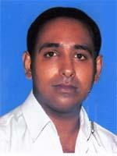 | DR. MD. ASIF SAZZAD  F/Name: Dr. Md. Mozaffar Hossain Talukder  M/Name: Mst. Afroz Jahan  BM & DC Reg. No: 78296  NID: 6125211184070  Cell: 01711390205  Address: 133, R.K. Mission Road, Newmohol, Mymensingh  Blood Group: AB+
503 | Voter No  LM-4100503  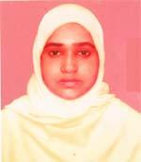 | DR. ZUBAIDA GULSHAN ARA  F/Name: Md. Ziaul Islam  M/Name: Nurun Nahar Begum  BM & DC Reg. No: 28869  NID: 6125221271040  Cell: 01731953154  Address: Goduli, 47/2/1, Bolashpur, Kewatkhali, Mymensingh  Blood Group: O+
504 | Voter No  LM-4100504  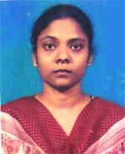 | DR. ANJUMAN ARA  F/Name: Md. Ismail Hossain  M/Name: Mst. Hasna Khatoon  BM & DC Reg. No: 38524  NID: 6125210182257  Cell: 01711232907  Address: 18, Shaheb Ali Road, Notun Bazar, Mymensingh  Blood Group: O+
505 | Voter No  LM-4100505  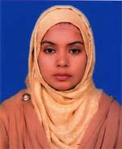 | DR. DILRUBA AFROSE MILI  F/Name: Md. Afsar Uddin  M/Name: Mursheda Khatun  BM & DC Reg. No: 49587  NID: 6125210175314  Cell: 01718515061  Address: 42/2, Prottasha Tower, Boundary Road, Mymensingh  Blood Group: A+
506 | Voter No  LM-4100506  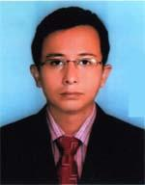 | DR. AVIJIT DAS  F/Name: Monindra Chandra Das  M/Name: Late Jharna Rani Das  BM & DC Reg. No: 61380  NID: 6125207154874  Cell: 01712972474  Address: 10/KA, Sherpur Road, Amlapara, Sherpur, Mymensingh-2200, Sadar  Blood Group: B+
507 | Voter No  LM-4100507  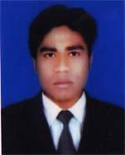 | DR. SHAIKH SHARIFUL ISLAM  F/Name: Shaikh Zakaria  M/Name: Sharin Bagum  BM & DC Reg. No: 65875  NID: 8728209132162  Cell: 01710369588  Address: Winmerpar, Chairmans Bari, Churkhi, Mymensingh Sadar, Mymensingh  Blood Group: B+
508 | Voter No  LM-4100508  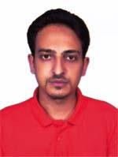 | DR. REZWANUR RAHMAN  F/Name: Late Md. Abdus Salam  M/Name: Rowshan Ara  BM & DC Reg. No: 70753  NID: 8928805131841  Cell: 01779105936  Address: Sherpur Town, Sherpur  Blood Group: A+
509 | Voter No  LM-4100509  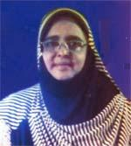 | DR. SHAMIMA SULTANA  F/Name: Mosslehuddin Ahmed (late)  M/Name: Rezia Begum (late)  BM & DC Reg. No: 15549  NID: 6125214204794  Cell: 01711191989  Address: 4/c, Medical staff Quarter, Charpara, Mymensingh  Blood Group: A+
510 | Voter No  LM-4100510  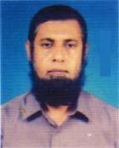 | DR. A. S. M. SHAHIDULLAH  F/Name: A. A. Syef Uddin  M/Name: Rabeya Akhter Khatun  BM & DC Reg. No: 15548  NID: 6125214204793  Cell: 01911701779  Address: 4/C, Medical staff Quarter, Charpara, Mymensingh  Blood Group: O+
511 | Voter No  LM-4100511  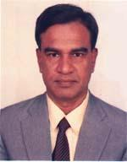 | DR. NIZAMUL KARIM KHAN  F/Name: Fazlul Karim Khan  M/Name: Mahmuda Khan  BM & DC Reg. No: 13473  NID: 6125214208026  Cell: 01711174361  Address: Professor of Endocrinology, Mymensingh Medical College , Charpara, Mymensingh  Blood Group: O+
512 | Voter No  LM-4100512  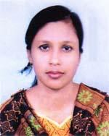 | DR. MOWMITA SHARMIN  F/Name: Md. Mokbul Ali  M/Name: Rokeya Khanam  BM & DC Reg. No: 37942  NID: 19812696828673031  Cell: 01716296002  Address: 7/C, 1st Floor, Hospital staff Quarter, Charpara, Mymensingh  Blood Group: n_a
513 | Voter No  LM-4100513  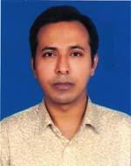 | DR. MOHAMMAD WAHIDUR RAHMAN  F/Name: Mohammad Abdul Khaleque  M/Name: Sarabon Tohura  BM & DC Reg. No: 37957  NID: 19802696828673030  Cell: 01712596769  Address: 7/c, 1st Floor, Hospital Staff Quarter, Charpara, Mymensingh  Blood Group: O+
514 | Voter No  LM-4100514  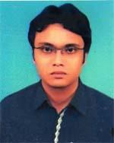 | DR. MITHUN RUDRA  F/Name: Hemanga Chandra Rudra  M/Name: Shila Rani Rudra  BM & DC Reg. No: 65684  NID: 6125209174212  Cell: 01714069413  Address: 21, A, Moharaja Road, Mymensingh  Blood Group: AB+
515 | Voter No  LM-4100515 | DR. MOHAMMAD MUKTADEER AREFIN  F/Name: Md. Abdur Rouf  M/Name: Mamataz Begum  BM & DC Reg. No: 39246  NID: 19802695433105124  Cell: 01711952671  Address: Department of ENT, Mymensingh Medical College Hospital  Blood Group: B+
516 | Voter No  LM-4100516  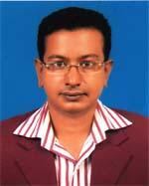 | DR. SAUROBH SARKER  F/Name: Sudhir Chandra Sarker  M/Name: Setu Rani Sarker  BM & DC Reg. No: 52471  NID: 6125207155425  Cell: 01729091549  Address: 5 No. Sherpur Road, Amlapara, Mymensingh  Blood Group: B+
517 | Voter No  LM-4100517  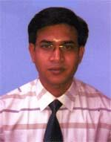 | DR. LIMAN KUMAR DHAR  F/Name: Kali Pada Dhar  M/Name: Mira Rani Dhar  BM & DC Reg. No: 39760  NID: 8928804120071  Cell: 01735198433  Address: Asst. Prof. (Plastic Surgery), MMC, 2/D, Charpara Medical Quarter, Mymensingh  Blood Group: O+
518 | Voter No  LM-4100518  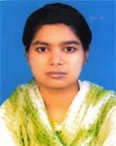 | DR. ANONYA TALUKDER  F/Name: Madon Mohan Talukder  M/Name: Mina Rani Talukder  BM & DC Reg. No: 38298  NID: 9329514305710  Cell: 01716115131  Address: Registrar (Obs &Gynee) , Mymensingh Medical College Hospital, Mymensigh  Blood Group: A+
519 | Voter No  LM-4100519  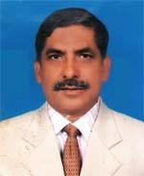 | DR. MOHAMMAD AZIZUL HOQUE  F/Name: Md. Safir Uddin Talukder  M/Name: Nabijan Bibi  BM & DC Reg. No: 14264  NID: 6125214203806  Cell: 01711403774  Address: 27/2, Karae Ghore, Naya Para, Char para, Mymensingh Sadar, Mymensingh  Blood Group: A-
520 | Voter No  LM-4100520 | DR. MUHAMMAD JAKIR HUSSAIN  F/Name: Muhammad Abubaker Siddique  M/Name: Mrs. Laila Parvin  BM & DC Reg. No: 37252  NID: 19796125214203386  Cell: 01711047700  Address: Nayapara House No.-49/2, Medical College Gate No. 02, Mymensingh Sadar, Mymensingh  Blood Group: O+
521 | Voter No  LM-4100521  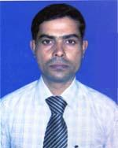 | DR. MOHAMMAD SAIFUL ISLAM  F/Name: Late Kofil Uddin  M/Name: Mosammat Sulema Khatun  BM & DC Reg. No: 29998  NID: 8913717880425  Cell: 01712190330  Address: 93, R.K Mission Road, Mymensingh  Blood Group: A+
522 | Voter No  LM-4100522  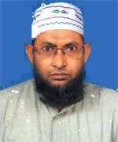 | DR. MD. ENAMUL HOQUE KHAN  F/Name: Md. Johur Uddin Khan  M/Name: Aziza Khatun  BM & DC Reg. No: 22094  NID: 6125214204414  Cell: 01718126965  Address: Tamanna Palace, 187, Rk Mission Road, Nwemohol, Mymensingh  Blood Group: n_a
523 | Voter No  LM-4100523  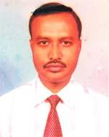 | DR. DULAL CHANDRA PANDIT  F/Name: Arun Chandra Pandit  M/Name: Joyshna Rani Pandit  BM & DC Reg. No: 21926  NID: 6125216217416  Cell: 01711613735  Address: Mohona, 27-Saheb ali road, Notun Bazar, Mymensingh  Blood Group: A+
524 | Voter No  LM-4100524 | DR. MOHAMMAD MOSHIOUR RAHMAN  F/Name: Mohammad Abdul Muttalab  M/Name: Ayesha Akter  BM & DC Reg. No: 40584  NID: 6115223669603  Cell: 01712562924  Address: Anaesthesilogist, Dept. of Anaesthesia & Icu, Mymensingh Medical College Hospital, Mymensingh  Blood Group: AB+
525 | Voter No  LM-4100525  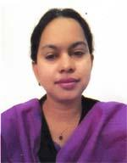 | DR. ASMA BEGUM  F/Name: Abdur Rahman  M/Name: Shamsun Nahar  BM & DC Reg. No: 40583  NID: 6115223669604  Cell: 01758384384  Address: Mymensingh Medical College, Mymensingh  Blood Group: B+
526 | Voter No  LM-4100526 | DR.MD. ASHIQUR RAHMAN  F/Name: Malik Md. Abdul Kadir  M/Name: Atika  BM & DC Reg. No: 50059  NID: 6125208163308  Cell: 01712092658  Address: Registran, ENT, Mymensingh Medical College  Blood Group: B+
527 | Voter No  LM-4100527  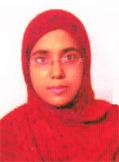 | DR. SABIKUN NAHAR  F/Name: Kazi Enamul Haque  M/Name: Khoshnahar Begum  BM & DC Reg. No: 43333  NID: 19826125205135413  Cell: 01717670349  Address: 25/Kha, Sankipara, Cantonment Road, Mymensingh  Blood Group: A+
528 | Voter No  LM-4100528  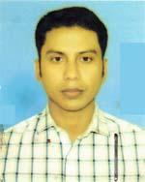 | DR. SREE MANASH BANIK  F/Name: Azit Banik  M/Name: Bina Banik  BM & DC Reg. No: 50060  NID: 6121302611695  Cell: 01712080377  Address: Dept. of Orthopaedics, MMCH  Blood Group: A+
529 | Voter No  LM-4100529  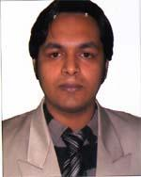 | DR. FUAD BIN AMIN  F/Name: Md. Nurul Amin Akanda  M/Name: Fatema Khatun  BM & DC Reg. No: 67955  NID: 6125219250310  Cell: 01712738937  Address: 97/12 Kalibari Road, Mymensingh  Blood Group: A+
530 | Voter No  LM-4100530 | DR. MD. TARIQUL ISLAM KHAN WASIM  F/Name: Md. Abdul Mannan Khan  M/Name: Mrs. Ashrafunnesa  BM & DC Reg. No: 37547  NID: 6125217229268  Cell: 01714035338  Address: 2/3, Gohail kandi , Zamtola mor, Mymensingh  Blood Group: O+
531 | Voter No  LM-4100531  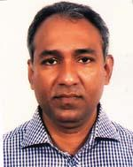 | DR. MOHAMMAD ASADUJJAMAN  F/Name: Md. Fazlul Haque  M/Name: Mrs. Momena Akhter  BM & DC Reg. No: 28599  NID: 6125217230630  Cell: 01711363426  Address: Dept. of Nephnology, Mymensingh Medical College Hospital, Mymensingh  Blood Group: O+
532 | Voter No  LM-4100532  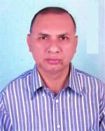 | DR. A. K. SALEH UDDIN AHAMMED  F/Name: Hafiz Uddin Ahammed  M/Name: Sufia Khatun  BM & DC Reg. No: 22989  NID: 19676128105015735  Cell: 01712200074  Address: Skymoon, 13/1, Boundary Road, Mymensingh  Blood Group: A+
533 | Voter No  LM-4100533  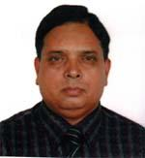 | DR. ASHUTOSH SAHA ROY  F/Name: Manoranjan Saha Roy  M/Name: Bakul Rani Saha Roy  BM & DC Reg. No: 20872  NID: 6125207283001  Cell: 01710893852  Address: 5/1, Sherpur Road, Amlapara, Mymensingh  Blood Group: AB+
534 | Voter No  LM-4100534 | DR. MD. ANOWAR HOSSAIN  F/Name: Md. Jasim Uddin  M/Name: Mrs. Hamida Khatun  BM & DC Reg. No: 33524  NID: 19768524902011284  Cell: 01711111179  Address: 40, Bagmara, Sadar, Mymensingh  Blood Group: B+
535 | Voter No  LM-4100535  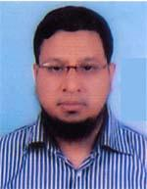 | DR. MOHAMMAD KHURSHED AHAMGIR  F/Name: Late Abdullah Al Hasan  M/Name: Nur E Ferdous  BM & DC Reg. No: 44569  NID: 8918874293116  Cell: 01718409284  Address: Kulsum Mongil, 29 Maskanda, Mymensingh  Blood Group: AB+
536 | Voter No  LM-4100536  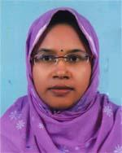 | DR. SALMA CHOWDHURY  F/Name: Din Gaffar Chowdhury  M/Name: Mrs. Shahanaj Gaffar  BM & DC Reg. No: 49689  NID: 7611684114057  Cell: 01717890543  Address: Kulsum Monjil, 29 Maskanda, Mymensingh  Blood Group: AB+
537 | Voter No  LM-4100537  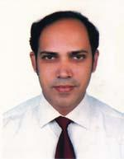 | DR. BISWAJIT CHOWDHURY  F/Name: Late Nirendra Chowdhury  M/Name: Bina Chowdhury  BM & DC Reg. No: 35937  NID: 6125207157331  Cell: 01715037516  Address: 9/1, Harikishore roy road, Mymensingh Town, Mymensingh  Blood Group: A+
538 | Voter No  LM-4100538 | DR. MITHUN KUMAR BAKSHI  F/Name: Dilipe Kumar Bakshi  M/Name: Anita Bakshi  BM & DC Reg. No: 40799  NID: 6125210176756  Cell: 01717563189  Address: 20/1 Jamir Munshi Lane, Nuton Bazar, Mymensingh  Blood Group: A-
539 | Voter No  LM-4100539  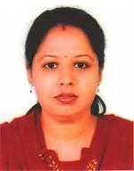 | DR. SHUKLA DEY  F/Name: Anil Chandra Dey  M/Name: Lila Dey  BM & DC Reg. No: 41729  NID: 6125208164087  Cell: 01717116587  Address: 20/1 Jamir Munshi Lane, Nuton Bazar, Mymensingh  Blood Group: O+
540 | Voter No  LM-4100540  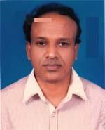 | DR. HARIMOHAN PANDIT  F/Name: Onil Chandra Pandit  M/Name: Charu Debi  BM & DC Reg. No: 36184  NID: 6125217236102  Cell: 01712212086  Address: N/G, Medical staff Quarter, Chorpara, Mymensingh  Blood Group: B+
541 | Voter No  LM-4100541  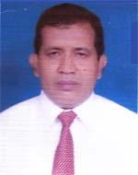 | DR. MD. AYUB ALI  F/Name: Md. Shahab Uddin Sarkar  M/Name: Mst. Amena Khatun  BM & DC Reg. No: 16778  NID: 19629329514304764  Cell: 01718033762  Address: Assoc. Prof. (CC), Neonatology Dept. Mymensingh Medical College  Blood Group: O+
542 | Voter No  LM-4100542  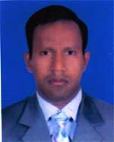 | DR. PREETE RANJAN ROY  F/Name: Kanai Lal Roy  M/Name: Dulali Roy  BM & DC Reg. No: 44787  NID: 6125220260128  Cell: 01716263662  Address: 12/17, Barmon Para, Kawatkhali, Mymensingh-2201  Blood Group: O+
543 | Voter No  LM-4100543  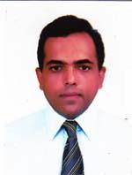 | DR. MOHAMMAD HANUN UR RASHID  F/Name: Mohammad Nur Nabi  M/Name: Monowara Begum  BM & DC Reg. No: 31970  NID: 2699038616254  Cell: 01715240679  Address: Assistant Professor, Nerosurgery Dept. Mymensingh Medical College  Blood Group: B+
544 | Voter No  LM-4100544  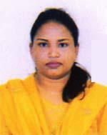 | DR. SIMLA AFTAB SHAON  F/Name: Md. Aftab Uddin Bhuiyan  M/Name: Mrs. Reazol Zinnat Begum  BM & DC Reg. No: 36211  NID: 6125614203790  Cell: 01712846829  Address: 58/A/2, Purhit Para, Mymensingh  Blood Group: A+
545 | Voter No  LM-4100545  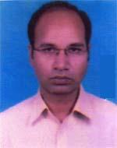 | DR. RAIHAN ROTAP KHAN  F/Name: Abdus Salam Khan  M/Name: Rokeya Sultana  BM & DC Reg. No: 36425  NID: 6125214203789  Cell: 01711070379  Address: 58/A/2, Purohit Para, Sadar, Mymensingh  Blood Group: O+
546 | Voter No  LM-4100546  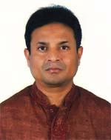 | DR. GOBINDA KANTI PAUL  F/Name: Kamal Kanti Paul  M/Name: Chayaa Rani Paul  BM & DC Reg. No: 25285  NID: 6125208160849  Cell: 01711940819  Address: 13/I, Skymoon, Boundary Road, Mymensingh Sadar  Blood Group: B+
547 | Voter No  LM-4100547  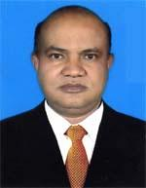 | DR. MD. ZAHIDUL ISLAM  F/Name: Late Abdul Hamid  M/Name: Mrs. Azizun Nahar  BM & DC Reg. No: 18242  NID: 6112211111781  Cell: 01712628466  Address: Amina Mansion, 21, Medical College Gate, Charpara, Mymensingh  Blood Group: B+
548 | Voter No  LM-4100548  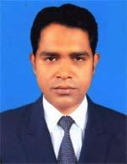 | DR. MD. MONSUR HALLAZ  F/Name: Md. Sahab Uddin  M/Name: Mrs. Saleha Begum  BM & DC Reg. No: 47767  NID: 8524901005971  Cell: 01731989799  Address: 114, Charpara, Maushati Tower, Mymensingh Sadar  Blood Group: O+
549 | Voter No  LM-4100549 | DR. SHAH ASHIFUZZAMAN (SAYAN)  F/Name: Shah Maksudur Zaman  M/Name: Afroza Begum  BM & DC Reg. No: 67227  NID: 6125213200030  Cell: 01743463760  Address: 20, Shehora Dhupa Khola, Mymensingh, Sadar  Blood Group: B+
550 | Voter No  LM-4100550  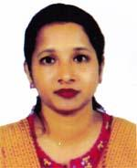 | DR. FAHMIDA SULTANA  F/Name: A. M. Mujibur Rahman  M/Name: Rabeya Khatun  BM & DC Reg. No: 33491  NID: 2610413976818  Cell: 01711703416  Address: 53/Ka, Shankipara, Mymensingh Sadar, Mymensingh  Blood Group: B+
551 | Voter No  LM-4100551  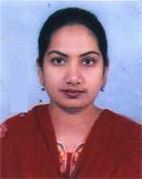 | DR. SARMIN SULTANA SHIKHA  F/Name: Altaf Hossain  M/Name: Jahanara Hossain  BM & DC Reg. No: 40557  NID: 6125215212834  Cell: 01712532742  Address: N/B Doctors staff Quarter, Charpara, Mymensingh  Blood Group: B+
552 | Voter No  LM-4100552  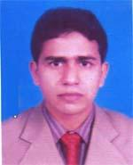 | DR. MUHAMMAD MOHSIN  F/Name: Md. Rukun Uddin  M/Name: Mrs. Hasina Murshed  BM & DC Reg. No: 29459  NID: 6125215212844  Cell: 01711224496  Address: N/B, Medical staff Quarter, Charpara, Mymensingh  Blood Group: B+
553 | Voter No  LM-4100553  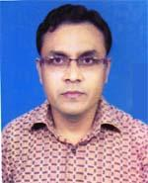 | DR. A. S. M. SHAFIQUL ISLAM  F/Name: Yunus Ali Mondal  M/Name: Sufia Khatun  BM & DC Reg. No: 28457  NID: 6125221271042  Cell: 01711425034  Address: Ghudhuli, 47//2/1, Balashpur kewatkhali, Mymensingh  Blood Group: AB+
554 | Voter No  LM-4100554  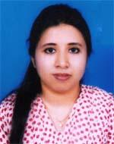 | DR. RAUNAK ARA AMIN RULY  F/Name: Md. Ruhul Amin  M/Name: Sayeda Gulshan Ara  BM & DC Reg. No: 49157  NID: 6125205138153  Cell: 01721145506  Address: 16/A, Mohammad Ali road, Mymensingh  Blood Group: O+
555 | Voter No  LM-4100555  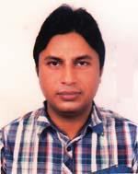 | DR. MOHAMMAD AL WALID SHARKER  F/Name: Md. Asaduzzaman Sharker  M/Name: Mrs. Sorufa Begam  BM & DC Reg. No: 37517  NID: 8916728561514  Cell: 01748983939  Address: Dept. of Cardiology, MMCH  Blood Group: O+
556 | Voter No  LM-4100556  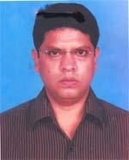 | DR. MOHAMMAD SAIFUL ISLAM KHAN  F/Name: Md. Arshad Ali Khan  M/Name: Mrs. Noorjahan Akter Khanam  BM & DC Reg. No: 37337  NID: 6125214207311  Cell: 01711075044  Address: 40/1, Naya Para, Charpara, Mymensingh  Blood Group: A+
557 | Voter No  LM-4100557  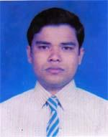 | DR. MOHAMMAD MUSTAFIZUR RAHMAN BIPLAB  F/Name: Mohammad Abdul Jabber  M/Name: Sufia Khatun  BM & DC Reg. No: 39648  NID: 6125206148937  Cell: 01716007709  Address: House No. 3/A, Medical staff Quarter, Charpara, Mymensingh  Blood Group: B+
558 | Voter No  LM-4100558  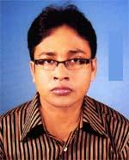 | DR. SUDHIR CHANDRA PAUL  F/Name: Hari Mohon Paul  M/Name: Usha Rani Paul  BM & DC Reg. No: 48934  NID: 9324703498915  Cell: 01722958597  Address: 43, Baghmara, Mymensingh  Blood Group: B+
559 | Voter No  LM-4100559  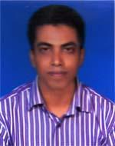 | DR. MD. SAIFUL ISLAM  F/Name: Md. Jalal Uddin  M/Name: Mrs. Rehena Begum  BM & DC Reg. No: 48224  NID: 19846125202114516  Cell: 01716798800  Address: N/A, Hospital Quarter, Charpara, Mymensingh  Blood Group: O+
560 | Voter No  LM-4100560  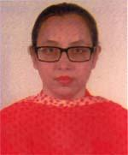 | DR. EMILY RAHMAN KHAN  F/Name: Bazlur Rahman Khan  M/Name: Rezia Khan  BM & DC Reg. No: 39647  NID: 6125206148922  Cell: 01712477505  Address: House No. 3/A, Medical staff Quarter, Charpara, Mymensingh  Blood Group: B+
561 | Voter No  LM-4100561  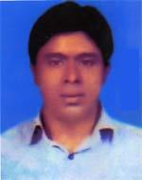 | DR. MITHUN KKUMAR SARKER  F/Name: Ratan Kumar Sarker  M/Name: Anjaly Rani Sarker  BM & DC Reg. No: 60084  NID: 3328601007168  Cell: 01716381529  Address: Swapranir Tower, Flat-7/B, Ck Ghose Road, Mymensingh  Blood Group: O+
562 | Voter No  LM-4100562  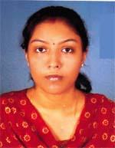 | DR. ANANYA DAS  F/Name: Amal Kanti Das  M/Name: Sobita Das  BM & DC Reg. No: 48935  NID: 9324703498914  Cell: 01717544666  Address: 43, Bagmara, Mymensingh  Blood Group: A+
563 | Voter No  LM-4100563  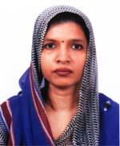 | DR. ANJUMAN ARA BEGUM SHILPI  F/Name: A.y. M. Abdul Malek  M/Name: Late Mrs. Rezia Begum  BM & DC Reg. No: 38751  NID: 19796125205139388  Cell: 01717222219  Address: 11/Ka, Gulkibari, Majeda Villa, Mymensingh  Blood Group: A+
564 | Voter No  LM-4100564  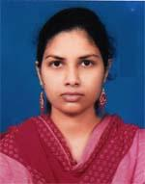 | DR. PINKI DAS  F/Name: Gopal Chandra Das  M/Name: Gita Dey  BM & DC Reg. No: 55067  NID: 8524904052525  Cell: 01724655824  Address: 17/1, Gulkibari Road, Mymensingh  Blood Group: B+
565 | Voter No  LM-4100565  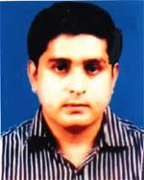 | DR. SUBRATA KUMAR PAUL  F/Name: Sushil Chandra Paul  M/Name: Bina Rani Paul  BM & DC Reg. No: 41079  NID:  Cell: 01718469043  Address: 17/1, Gulkibari Road, Sadar, Mymensingh  Blood Group: O+
566 | Voter No  LM-4100566  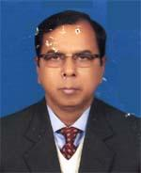 | DR. MD. MOTIUR RAHMAN  F/Name: Late Sujar Uddin Talukder  M/Name: Late Zubedun Nessa  BM & DC Reg. No: 13288  NID: 612510176077  Cell: 01711232594  Address: 9/ga/3, Hori Kishor Roy Road, Mymensingh  Blood Group: O+
567 | Voter No  LM-4100567  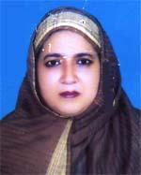 | DR. FERDOWS ARA AKTER  F/Name: Md. Khorshed Alam  M/Name: Mrs. Jeebon Nesa  BM & DC Reg. No: 20841  NID: 6125210176078  Cell: 01715404949  Address: 9/Ga/3 Horikishor Roy Road, Mymensingh  Blood Group: AB+
568 | Voter No  LM-4100568  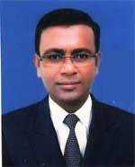 | DR. ABUL KASHEM MUHAMMAD MUSTAFIZUR RAHMAN MINTO  F/Name: Mohammad Alim Uddin  M/Name: Asia Alim  BM & DC Reg. No: 36358  NID: 19786125205135415  Cell: 01711935365  Address: 25/Kha, Shankipara, Cantonment Road, Mymensingh  Blood Group: O+

